# PAGE 1

[blog](https://j-s-5t52.squarespace.com/)[about](https://j-s-5t52.squarespace.com/about)

[tbi life](https://j-s-5t52.squarespace.com/)

stories and advice

# my story

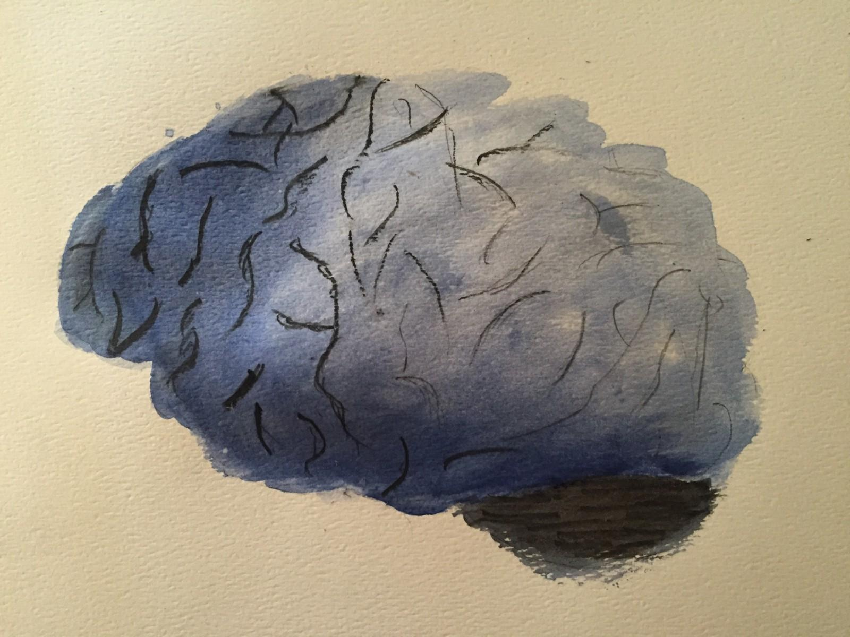

**March 2016**

My brain has not been pulling its weight lately. Here’s what it feels like.

**the impact**

My go-to first round question used to be ‘never have I ever had a concussion.’

In December I slipped, fell down a few feet, and landed directly on my forehead. When I came to, maybe only a second later, my first thought was “ok that was really hard.” Then, “I need to get up so everyone thinks I’m fine…and wow this is how NFL players must feel when they want to stay in the game after a hit.”

That night I threw up and the following two days were two of the worst of my life. Every source of light and word spoken above a whisper caused sharp pain. My balance was off and trying to think made me nauseous.

Maybe I was too out of it to realize something was really off. I assumed it was a shitty hangover with a little something extra that would pass in a few days. That Monday I went to work with a hat and my boss told me to go to the hospital.

The first few weeks I wasn’t so much in denial as unable to process what was happening. Yes, I was sleeping eleven hours a day. Yes, after a lifetime sans headaches my brain hurt all the time. I couldn’t focus for more than a paragraph or two. I got pulled over for driving erratically. At work, by the afternoon I was so nauseous I couldn’t sit up straight.

But I’ve lived with the same brain for twenty-five years. For awhile it was impossible to conceptualize what WebMd meant by concussions causing “cognitive problems involving memory, concentration, and thinking.” My brain has never been impaired for more than a few hours at a time.

Imagine you’ve woken up from a long night out where you only got a handful of hours of sleep. It’s like that, but different.

**cognitive issues**

So the generic symptoms are pretty draining. I get nauseous after looking at a screen for long. Concentrating on anything unfamiliar is a struggle and eventually gets painful. It takes real effort to follow and participate in a conversation longer than thirty minutes, and I need a break after an hour. Extended exposure to noise is mentally fatiguing and makes my ears ring for days. I can’t drink or exercise. Very few things used to put me in sour moods for long but now my emotional ‘flex’ tops out at what I used to have after five hours sleep.

Putting all of the above aside, the cognitive slowdown has been the most unnerving. It’s so much more nuanced than what a concussion protocol could reveal.

Imagine being unable to think in sentences with multiple clauses without pain. Paragraph-long thoughts out of the question. Where your brain used to unconsciously play out multiple scenarios at once, now you have to deliberately work your way through each one. The effort it takes to work through different options makes you more likely to stay on one track, both logically and emotionally. Visualizing complicated scenes in my mind’s eye is painful. New information, particularly about unfamiliar topics, hurts to toy around with and doesn’t stick.

The creepiest side effect has been making typos on easy words. I’ve made more “its/it’s, their/they’re” errors in the past few months than I have in the past ten years. Homonyms consistently trip me up. When trying to draw a sad face I put the eyes underneath, making it an upside down happy face instead. It’s as if my brain has to expend so much energy getting the other parts of writing right that it doesn’t have enough in the tank to do anything else. Assuming that this pattern applies more broadly, I’m scared to know what else my brain is missing.

Progress is uneven but it’s there. Every day is a crap shoot, but definitely I feel better than I did a month ago.

[Wear a helmet, folks](https://www.youtube.com/watch?v=x84m3YyO2oU).

**Mid-June 2016 — Relapse**

Relapses are real and really demoralizing. The pleasures I am used to — exercise, video games, music, socializing, watching sports, reading and listening to articles and books — I have since had to ration. On about four occasions after I spent two or three weeks feeling pretty good I have indulged (the Kanye fashion show, shooting hoops and jogging in the park, two hours of Overwatch followed by a west coast playoff game which I found incredibly joyous for whatever reason), only to condemn myself to two plus weeks of more severe tinnitus, nausea, and headaches before I get back to where I was prior.

Most recently, kayaking on a still lake and sitting on a pontoon boat over Memorial Day weekend has brought me to my lowest physical point since the first weeks after the concussion. The worst part with this one was that I feel like it wasn’t even my fault — the other times I was aware I was taking a calculated risk to test my limits but I had no idea my body would react this badly to being on water. This has also dropped me to a dramatic new low emotionally — partially due to the dramatic deterioration in my symptoms as well as the intense frustration of feeling like after six months (as long as it took 66-year-old Hillary Clinton to recover!) my brain isn’t any less fragile.

I recently got into Tim Ferriss who said somewhere in a podcast that titration of addictions is sometimes much harder from a willpower perspective than cutting off whole hog. Cutting yourself off from really human behaviors like listening to music, dancing, exercise, socializing and even thinking without paying an emotional price, particularly for someone whose natural brain state is one of hyperactivity, is just impossible without paying an emotional price. It’s also depressing knowing that I’m most likely to overexert myself when the endorphins start flowing and I’m happy and in ‘flow’, so I have to be wary of those times.

Thankfully, I’m now out of the 10-day dark room jail sentence my new doctor issued and can start to resume a semi-normal existence.

**July 2016 — A New Approach and Silver Linings**

The setback (and Tim Ferriss’ body book that’s all about how ‘conventional wisdom’ science is twenty years behind and that we should experiment with our bodies to figure out what works) prompted me to ditch my old doctors’ ‘just don’t try to push yourself too hard and wait it out’ and take a new approach. Now I’m doing every therapy under the sun and hoping something sticks.

* *Sensory deprivation floatation tanks that [Navy SEALS](https://www.naturalstacks.com/blogs/news/77817157-how-navy-seals-are-using-float-tanks-to-treat-concussions) apparently use for concussions. You’re floating in salt water and it’s so quiet you can hear yourself blink. I walked out of the session the most zen I’ve ever felt and the feeling lasted for days. It also eases off the symptoms pretty dramatically, giving your brain space to breathe, and they stay settled down for days afterwards. I really recommend this for anyone who’s stressed or anxious or just wants to feel like they’re going to the moon.
* **Biofeedback Heart Rate Variability breathing (20 minutes of breathing really slowly twice a day). Too soon to tell but it’s supposed to [activate some nervous system that’s locked in the on position post-concussion](http://www.ncbi.nlm.nih.gov/pmc/articles/PMC4131496/). [Here’s a good explanation of how it works](https://www.youtube.com/watch?v=9nwFUKuJSE0&app=desktop) — basically some scientists in the 70s hung out with different Yogis from all over the world, asked them to get “calm and centered,” and watched as everyone from Japanese zen masters to Tibetan monks slowed down their breathing to a really regular 5 breaths per minute. It helps relax the fight-or-flight nervous system that isn’t able to properly calm down post-concussion. Here for more on the autonomic nervous system.
* Meditation with my new best friend Andy from Headspace
* Stretching with the Flexivity app
* low-intensity body-weight exercises
* **Cardio at super low heart rates. I tried cardio before but I would always end up pushing myself too hard, get a terrible headache, feel bad for the next few days, and not try to exercise again for another month. A new doctor pointed me in the direction of this [Buffalo Protocol](https://www.researchgate.net/publication/258521687_Use_of_Graded_Exercise_Testing_in_Concussion_and_Return-to-Activity_Management) where you do twenty minutes of cardio at the heart rate just below where your symptoms kick in, then increase 5–10 bpm every week.
* *I have these incredibly ugly glasses from [Theraspecs](https://www.amazon.com/gp/product/B00F8QIKF8/ref=as_li_tl?ie=UTF8&tag=tl0b6-20&camp=1789&creative=9325&linkCode=as2&creativeASIN=B00F8QIKF8&linkId=dfd1398bc75585fd8d27ff98ff8f8c7e) that help with fluorescent light. [Note--this can screw up your sleep schedule if you use them during the day as it filters out the light that helps regulate your circadian rhythms. It also may create a dependency that ends up reinforcing your light sensitivity. Use with caution, maybe limiting to supermarkets and watching tv at night.]

So I don’t feel like I wasted a year of my life, it’s important to find/create silver linings. First off, I’m thankful that I can see good doctors, live at home in a supportive household, and don’t have major responsibilities I’d be stressed about shirking to recover. Had this happened in high school, college or god forbid a few years from now with a family, I would have been much more stressed about missing experiences and disappointing people relying on me.

Since I can’t develop any skills I’m really excited about (I’m working on drawing and cooking which is fun but not going to change the world…), and I already have a ton of different therapies to do every day, I’m most focused on habit-formation. This interview with Naval Ravikant, more than anything else, got me out of a funk. (It’s worth overlooking Tim Ferriss’ terrible interviewing style — Ravikant is just gold.)

"I had a health issue a few months back, which is a great wake up call. Everything great comes from something bad. Krishnamurti has this definition of suffering, where he says suffering is a moment when you see reality exactly as it is. When you face reality, that’s when you’ll change. It’s hard to look at suffering as a teacher but that’s how you should prepare yourself for it…I had a bacterial infection and my internal state was unhealthy. In one week I dropped alcohol, dairy, caffeine, red meat, went completely zero carb. All my bad habits disappeared overnight because my body was giving me a tight feedback loop. If I ate the wrong thing, I felt terrible.

That was a gift! When I’m 41, my turns around and tells me what to eat to be healthy. If I ate perfectly, then the symptoms were much better."

Learning how to make a habit, more than learning to code or whatever, is probably the useful thing I can come out of this experience with. For starters, I’m trying to stop putting off important tasks and hard conversations, be on time, and wean myself off iPhone dopamine hits.

To help remind me to do all of this, I’ve started on [Habitica](https://habitica.com/). It has a silly RPG scheme after downloading ten different habit apps this one has the most versatile features, the best app, and the deepest social integration. Plus you start to think of your little avatar as a Tamagotchi you don’t want to see die.

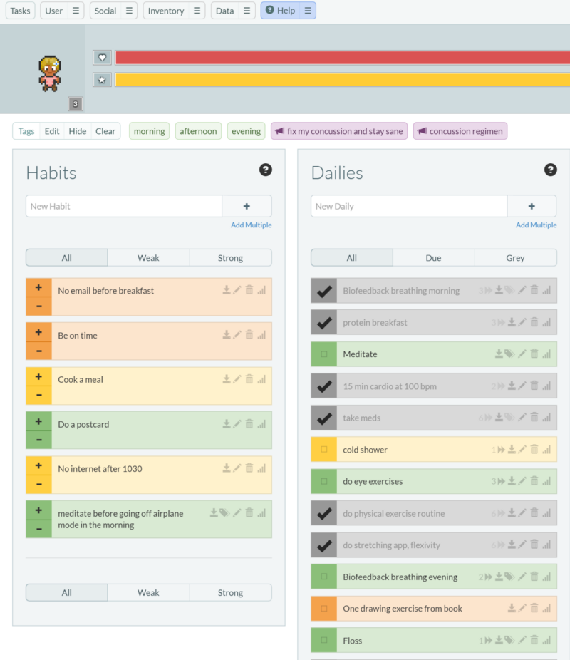

JORDAN SCHNEIDER

#### [DEAR MR. PRESIDENT](https://j-s-5t52.squarespace.com/blog/2017/1/12/dear-mr-president)

## SUBSCRIBE

SIGN UP

# PAGE 2

# Dear Mr. President



Three months a new job last year, at their holiday party where I tried my best to stay sober, I slipped off a stage and onto my forehead. When I came to, my first thought was, “I need to get up fast, so everyone thinks I’m fine…but this is how NFL players must feel when they want to show coach they should stay in the game.”

The impact touched off chronic pain, nausea, light, and noise sensitivity. I moved back home, went on disability and spent months in my bedroom with the blinds drawn.

After some dark days, I finally drummed up the willpower to rededicate myself to hours upon hours of therapies.

As a big Kanye fan, it crushed me over the summer that whenever he released a [new single](https://www.youtube.com/watch?v=fyfOvJ6ByIY), I could only make it through twenty seconds before my headache screamed to stop. But on my way to physical therapy on September 28th, something seemed to have clicked. A friend posted your Summer Playlist 2016, and I figured, what the hell, let’s see how far I could get.

Standing in Columbus Circle, I got all the way to Classic Man. The image of you listening to the lyrics “Get ’em, we’ll get ’em, I know that we’ll get ‘em/Cause I lived through this shit before” as pre-Putin negotiation hype music had me laughing in tears on the subway platform. When you spoke to our intern class, it felt like you were a cardboard cutout of “Barack Obama.” But this moment brought home to me that you are a real person, someone I could actually try to be like.

Reporter Cal Fussman recently lamented that my generation didn’t have heroes on the level of a Muhammad Ali. While, yeah, you’re no Ali, your grace, empathy, honesty, integrity, optimism, and conviction are all outstanding characteristics I hope to model in private life and perhaps one day as a public figure.

More than any other person outside my family, you have shaped the person I aspire to be. While it’s sad to think that my little brother will be going to college next year without you on tv every day to look up to, I am eternally grateful for the time I was able to learn from your example.

Thank you.

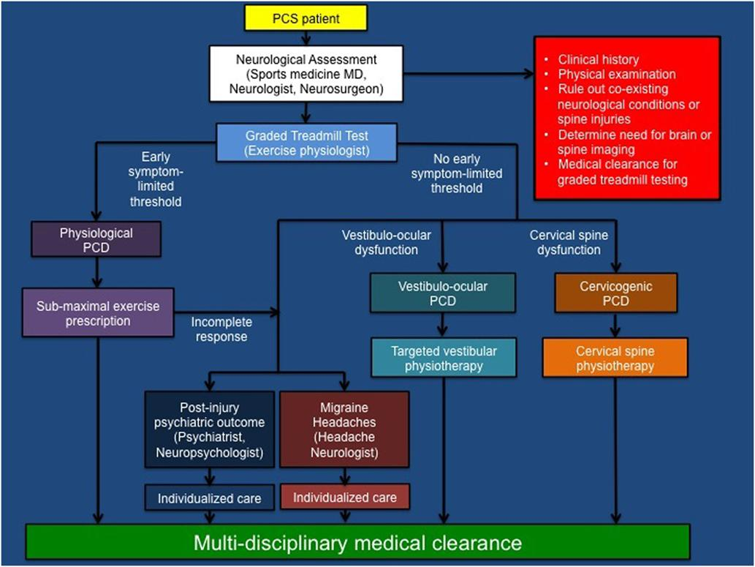

This chart and accompanying paper is the best summary of what goes wrong with post-concussion syndrome and how to address it. I don't feel qualified to summarize except to say that it has helped me develop a much deeper understanding of my symptoms and how to manage and combat them.

http://journal.frontiersin.org/article/10.3389/fneur.2016.00136/full

PAGE 3

# What no pain feels like



October 2016

For two weeks in October I hung out at [Myoworx](http://myoworx.com/) in Guelph, Ontario for a big battery of physiotherapy. Paige Decker wrote [a great explanation](http://www.theinvisibleinjury.net/blog/2016/3/29/22-how-the-myoworx-concussion-program-got-me-headache-free-for-the-first-time-in-over-two-years) of the theory behind Terry Moore's concussion treatment. Basically, the whiplash followed by bedrest and avoiding normal head movement tightens up your neck, trap, and shoulder muscles. The muscle spasms restrict blood flow to the brain and also pinch nerves that trigger symptoms.

When I came to Canada, the headache and nausea lived at a 4. I could only rotate my head 30 degrees in either direction and towards the end of that range I would feel pain on the bridge of my nose. My grip strength resembled more a frail 70-year-old than an amateur rock climber. At this point I had gotten used to the pain and nausea, though it left me constantly fatigued. Most intrusively, though, I couldn't hold my attention on a difficult task for more than 10 minutes.

In the first week, though a series of stim, stretching, and manual manipulation exercises, we changed the headache's quality from a rigid circle to more of a diffuse cloud of pain. We were also able to eliminate the pain from the left side of my forehead.

Over the weekend I noticed some symptom alleviation. My convergence insufficiency decreased and attention improved enough to let me read for longer and with less effort.

On Monday and Tuesday of the second week, the real magic happened. At first, I had a hard time doing the 'wave-y' motion required in many of the Myoworx stretching and strengthening techniques. My neck had spent so much time in rigid positions that I couldn't even conceive of what that movement meant. Watching more demonstrations and finally conceptualizing of it like a limbo move unlocked the motion for me.

Then through a series of stretches on the referral areas (generally a parallel slice behind where the pain is) we pushed the headache further and further to the right. I burst out laughing when we moved it to my temple. For the first time in nearly a year, my forehead didn't hurt. Subsequent stretches even gave me five seconds of complete head pain relief.

[it felt transgressive to push out the pain](https://j-s-5t52.squarespace.com/blog/2016/10/25/what-no-pain-feels-like)

Even something so unequivocally bad as head pain, when it's with you for so long, becomes familiar and almost comforting. For a whole year if I ever thought about how my head was doing (or if someone asked me how I was feeling) immediately I would notice my headache's level. It reminded me that I was ill, giving solace to a type-A personality that it was right to be on medical leave and having lazy days even with Donald Trump running for President. I'd imagine it would be similar to people glancing at their tattoos to remind themselves of something.

Then I thought about my doctors, and how many neurologists and physical therapists touched my neck and didn't notice anything particularly wrong. Perhaps in the first few months, my neck wasn't a big issue, and only after bed rest in early June did it lock up and begin to exacerbate symptoms. It's very frustrating to have spent months thinking I had these big psychological problems ('affective disorder' was my favorite bs diagnosis) only to it turn out to be something so mechanical as muscle spasms in my neck.

I still think there was tremendous value in the cardio, hrv breathing work, meditation, and sumatriptan, particularly in addressing mental health. But by attacking both the pain and the attention deficits (I was able to write this post in just one sitting), Myoworx has really worked wonders. This is a truly remarkable treatment and one which I wish I would've discovered sooner.

# Sumatriptan: A Magic Molecule

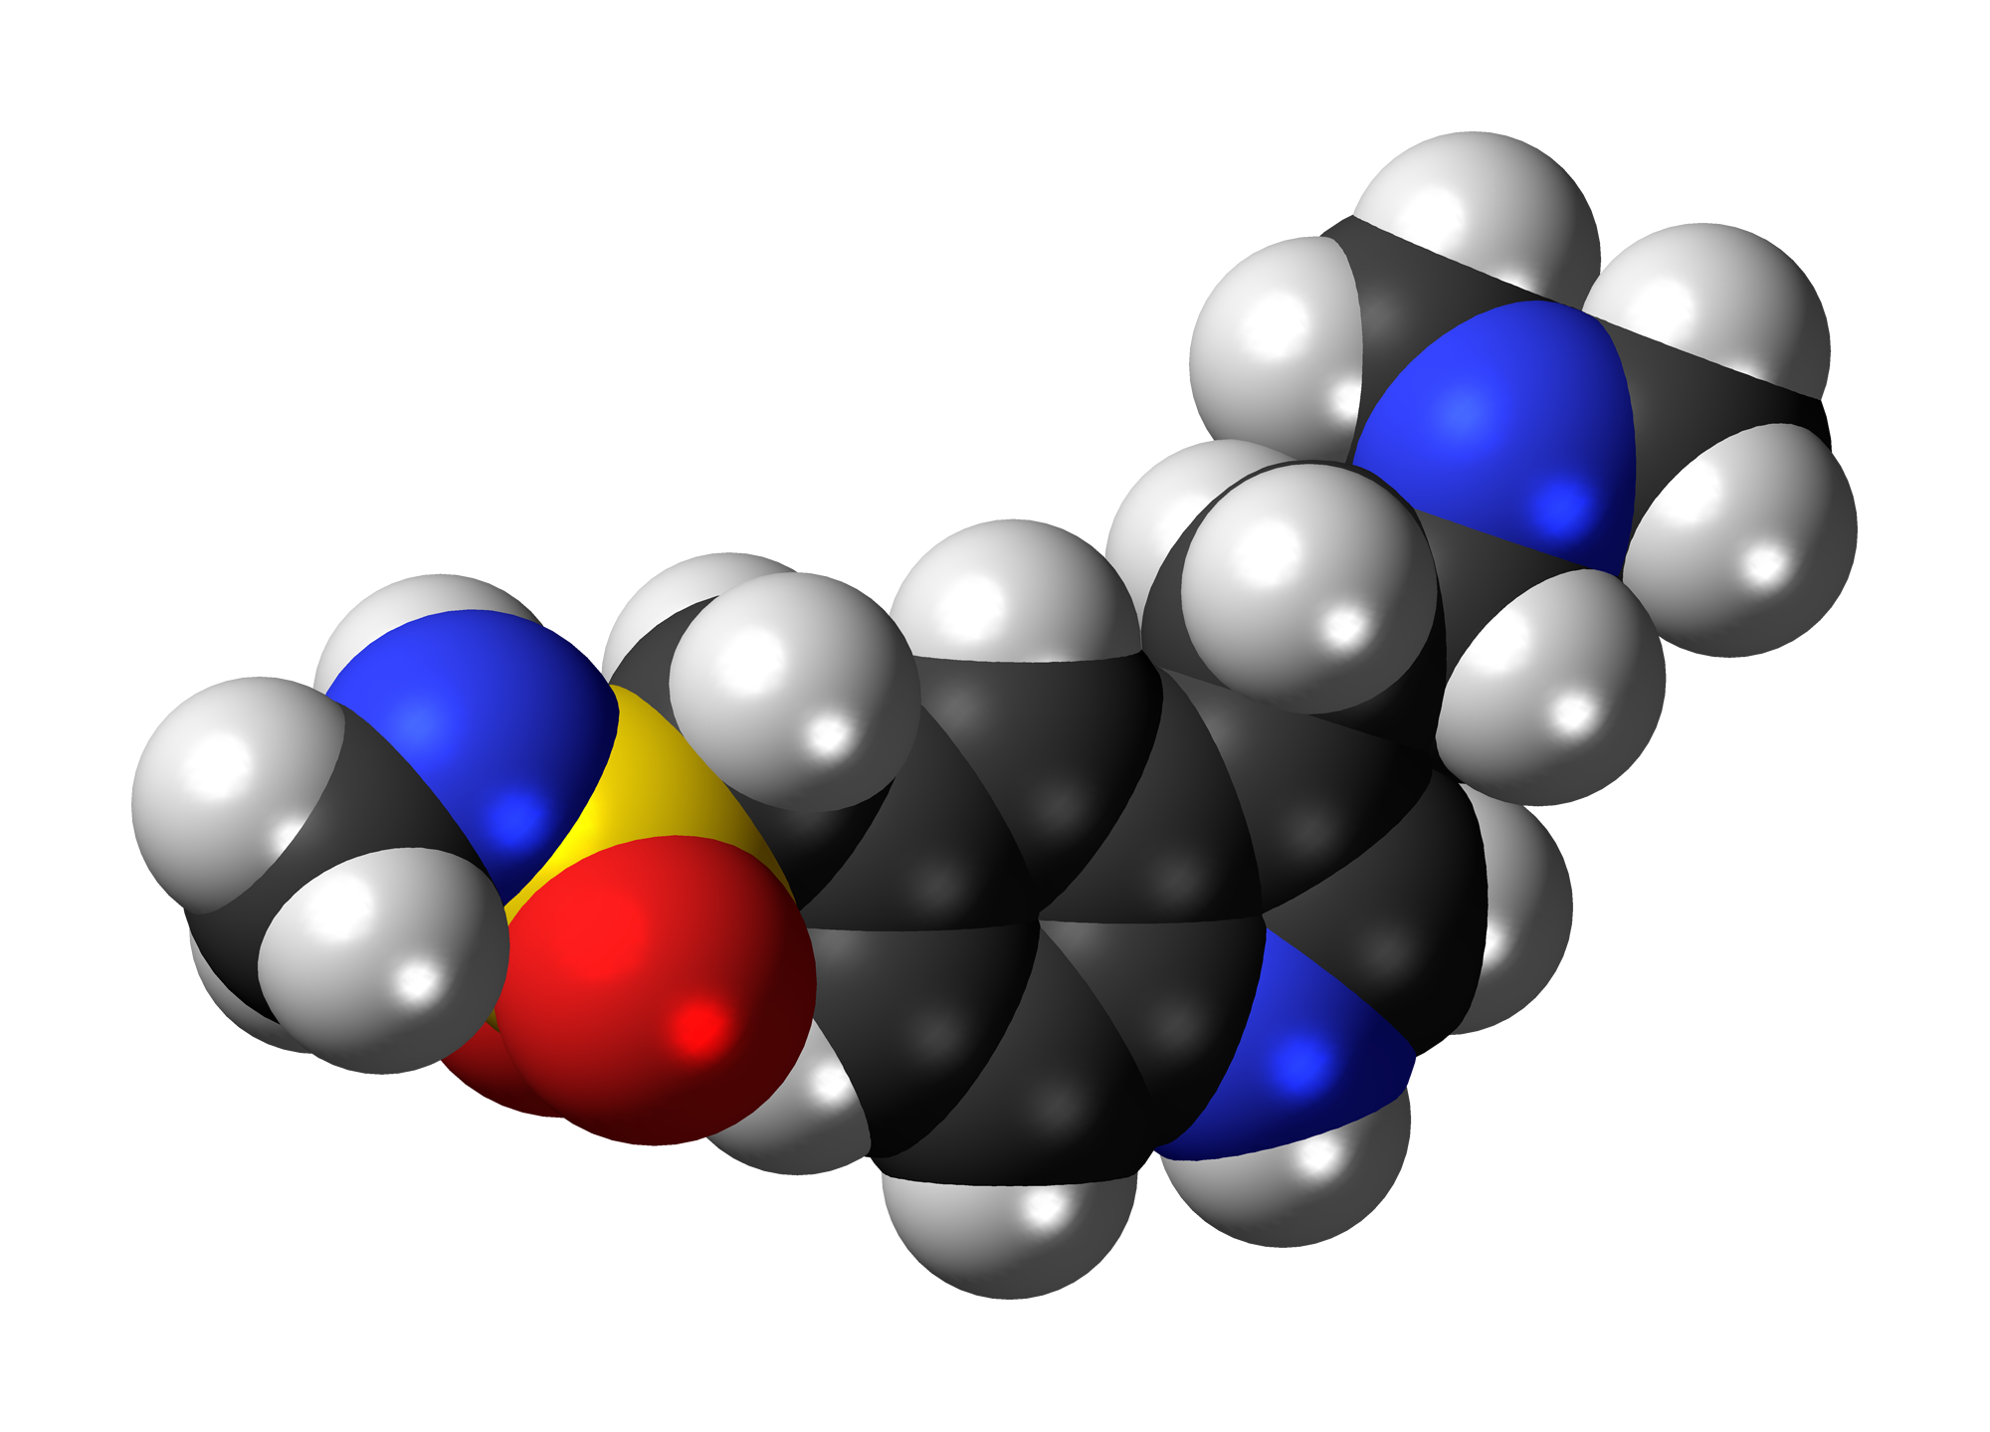

In March 2015 I went to a neurologist who was a headache specialist. She put me on three different pills—all old antidepressants in low doses that are supposed to help with concussion headaches (I remember Gabapentin)—that basically did nothing except make me groggy. At one point I remember explicitly asking her for normal migraine pills that they give to normal migraine patients, and she said something like "no, that's not your type of headache, it won't do anything for you."

Fast forward 6 months, I ask my new neurologist if he had any new headache ideas. I had been doing the biofeedback and cardio which helps to some degree but I basically live my life with a 4-6/10 pain headache about an inch and a half in diameter in the front of my forehead. He says, ok, sure, I'll send you to the special headache guy. [Dr. Mauskopf](https://nyheadache.com/) tells me to check out [sumatriptan](https://www.drugs.com/cdi/sumatriptan.html).

The next week, I met up with a friend outside a museum and ten minutes before she arrived popped a pill. I'd taken my nausea pill in the past before meeting up with friends and didn't think I was in for anything special.

Immediately it felt like a hard drug--my head went super light, my face had that [Weeknd](https://www.youtube.com/watch?v=KEI4qSrkPAs) feel...and then magically the pain goes from a 6 to a 3. Five minutes later, I got very sharp and defined level 4 pains at random parts of my head I'd never had headaches--it felt like there was a Men in Black alien in my head. Ten minutes later I'm still feeling like I'm on some sort of hard drug, but my forehead pain has gone down to a 2, which it usually only is for the first 2 minutes when I'm waking up. It stays this way all night.

This is a magic molecule.



At the time, I had mixed emotions. I was furious at modern medicine for not telling me to try this earlier, but at the same time grateful that after 8 months of doctors without good answers one they finally found one. I also weirdly feel like I didn't "earn" this relief by being super diligent with my habits in the way I did by stopping the random sharp headaches by fixing my posture.

But in the end...who cares! I got 4x more functional than I used to be! I could tolerate way more light and noise with this coursing through my neurons. It also has helped get the nausea under control. I was able to see Chappelle live and go to the US Open without falling apart. I could start watch more tv and hold conversations for longer. Though scared that its effect would eventually wear off, I was able to take sumatriptan less and less frequently, and today haven't used the pill in two months.

# Cardio



I always liked running to things. Up and down stairwells, coming back from grocery shopping, going from the train stop to a friend's party. But after the concussion, I couldn't jog more than ten seconds without triggering a headache.

My first neurologist a few weeks after impact just told me to 'try to get active again.' Telling this to a type-A former varsity athlete was the wrong idea. For the first few months, every few weeks I would try to go to the gym and do my normal workout, often triggering 9 or 10 headaches and once nearly fainting. I didn't want to accept that I couldn't run as hard or squat the same weight. At first, it wasn't my muscles atrophying, but rather the neurological strain of firing muscles overwhelming my system.

Thankfully I came across a [new neurologist](https://www.healthgrades.com/physician/dr-jonathan-silver-2n45w) and [PT team](http://nyulangone.org/locations/concussion-center) at NYU who had a better approach. The best research on proper return to cardio is the [Buffalo Protocol](https://www.researchgate.net/publication/258521687_Use_of_Graded_Exercise_Testing_in_Concussion_and_Return-to-Activity_Management) developed by Dr. Leddy at U of Buffalo. If you encounter a trainer who isn't aware of this study, they're not worth your time. The way it works is you walk on a treadmill at 3.6mph with a heart rate monitor on, and increase the incline every minute until your symptoms or heart rate spikes up. Once you hit that point, you then do 80% of that limit for 20 minutes a day, 5x a week, for two weeks, and then bump the ceiling up by 5 or 10 bpm.

A youtube explanation:

I started at 90bpm, barely above walking. Combining some training from heart rate variability I was able to settle my heart rate down through slow breathing when it spiked from the anxiety of anticipating pain.

About a month in I overreached. After two weeks of increasing by 10bpm each week, I got overconfident/stopped paying attention and spent about a few minutes up near 140bpm. For the next week I was bedridden. I'd recommend setting up your heart rate monitor to beep loudly whenever you go out of your target zone. Also, be sure to use one you strap to your chest as wrist-based heart rate monitors aren't as precise as you need them to be for the protocol.

It took another six weeks to make it back up to 125bpm, a range where I finally started sweating. That first endorphin rush after eight months of near sedentary living was better than sex. The positive impact both symptomatically and emotionally from getting active again were key to my recovery.

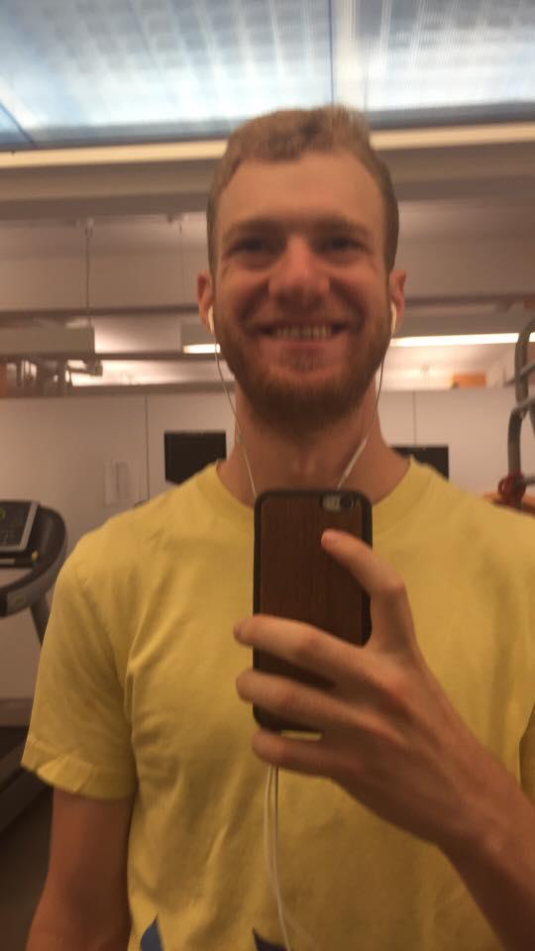

Today, 'bouncing' activities still cause issues. Jumping up and down playing basketball or running can trigger symptoms and make my head feel really heavy. But pushing myself with HIIT workouts on a bike a few times a week is such a joy.

# My Story Continued, Thoughts on Leadership

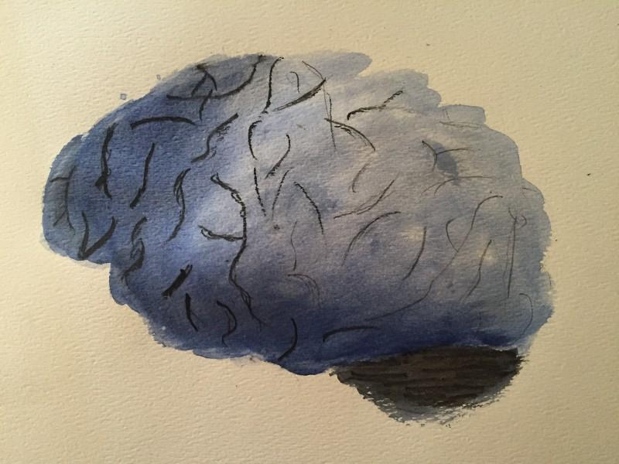

September 2016

I had it really good.

I grew up in a stable, loving home. I was blessed to attend schools that embraced my love of learning. I found a passion in world politics and jobs to help me pursue it. And I had caring friends who welcomed my energetic, outgoing and unfiltered personality.

Then, this past December, I fell six feet off a slippery stage onto my forehead. I got up fast but remember thinking, "This is what NFL players must feel like when they're hurt but don't want coach to take them out."

Initially, I couldn’t process that my brain wasn't the same. I had constant headaches and nausea. I grew uncharacteristically irritable and withdrawn. Even more distressing, I was unable to think in complicated sentences or mentally play out multiple scenarios without triggering pain.

Losing my intellectual agency was at first incomprehensible, and later incredibly demoralizing.

For the first six months, I had a hard time respecting my disability and the healing process. Hearing mixed messages from neurologists (some advising rest, others continuing life as usual), I followed the path of least resistance. While on medical leave, I still read, dated, lifted weights and hosted presidential debate-watching parties, often through excruciating pain. I was scared to admit to myself or anyone else just how sick I was.

This strategy created a vicious cycle. Trying my best to be my usual self, the pain would only crescendo, ultimately forcing me back into dark rooms.

After the third setback, I needed a new approach. I adopted a strategy of cutting out and then slowly increasing cognitive, social, and physical exertion. I had to replace the things I loved with a set of hobbies more comfortable in a nursing home than a dance hall. I couldn’t go straight back to my former life. But if I transformed my routines—and, critically, found fulfillment and joy in them—I could trudge inch by inch towards recovery.

I knew I didn't have the willpower to break out of my cycle alone. So, I wrote to my friends about my struggles and asked for help. I also zeroed in on three new hobbies that could give me a sense of progression—drawing, cooking, and meditation—as well as a regimen of cardio, posture, and eye exercises.

I hoped that by sharing my progress week to week, I would not just motivate myself to live up to my regimen but inspire my friends to install more positive habits as well. I created an account on Habitica, an activity tracker app with an RPG overlay, and invited friends and family to my guild.

I started sending weekly emails to my friends detailing my progress. I reveled in my successes ("Just listened to two songs in a row without my head exploding!"), and I honestly admitted my failings (“Watched too much Olympics and sped up my audiobook to 2x…and just fell back to where I was a month ago”). Forcing myself to reflect each week gave me a sense of improvement I didn't know I had made and helped me realize what was and wasn't working.

The longer I kept this up, the more I realized the weekly updates weren't impacting just me but my friends as well. One by one I received incredible emails like, “Jordan I know you feel like you’ve changed so much as a person, but two things I love about you—your enthusiasm to try new things and eagerness to bring different people together—are still very much present.”

Most powerfully, one friend opened up about his suicidal thoughts, concluding his message by saying, “If you're trying, I can follow suit.”

Only after I started receiving these emails did I recognize the power of my example. Once I got past my denial, I was able to embrace transparency and harness its power. What my openness did for my friends inspired me to start this website.

By setting an example, warts and all, I was able to encourage others to live up to it. Through this recovery process, I have developed a leadership style that I will always carry with me: to live honestly and openly.

No doubt, it has been a rocky and painful year. But in this year I have learned a tremendous amount about myself and my capabilities. I’ve uncovered reserves of ingenuity, resilience, determination and empathy I frankly didn’t know were there. I am now more confident than ever in my ability to do something meaningful with my life.

# Five Lessons From The Crash Reel



One day when I was down and feeling sorry for myself a friend suggested I watch The Crash Reel. It's the story of Kevin Pearce, a pro snowboarder who in 2008 and 2009 started beating Shaun White in competitions. Two months before the Vancouver Games, he had a terrible fall that left him with a TBI in the ICU for a month, and set him up for years of rehab. The documentary follows him and his family as they try to reconcile with his new brain.

You can find it on HBOGo for free and lots of other sites for three dollars. Those three bucks will far and away be the most cost effective medical expense.

So, why was this movie really great for me to watch?

1. Adding Perspective

Kevin spent most of entire life deriving flow and pleasure from one activity that in a moment was taken away from him forever. He struggled in school with severe dyslexia but found a success and a community on the slopes. He was both a savant and put in more work than his friends. He was on the verge of possibly proving he was the world's greatest in something until that very passion led to his TBI.

And me? Well, first and foremost I'm thankful I'm not dealing with symptoms nearly as severe as his. But aside from just the physical challenges, the psychological hurdle of having to accept that the one thing that you thought gave meaning to your life could kill you if you ever pursue it again is just enormous. I've always had a diverse set of interests but more importantly had the capability and mindset to get jazzed by almost anything. Though it has been a struggle having to abandon some of the things that really got me going the most (live music, reading hard books, drinking, dancing, pushing my body physically) I always had tier two and three interests that I could pursue. Watching someone to whom it seemed like their whole life disappeared reconcile with that was really inspiring--I took the message that if someone can come to terms with what he had to, my little challenges are small fry and I shouldn't mope about them.

2. The Mental Health Struggle

Kevin's mindset pre-concussion I can relate to. We were both are extreme extroverts who love sharing experiences with lots of friends. It seemed like we both always had the most positive attitude of the group and were the ones to bring the energy up.

At one point in the movie Pearce is talking about all the meds he takes and then he turns to his Lexapro. "I'm not sure why I'm taking this because I don't feel like I'm depressed, but here's my antidepressant."

3. Highlights How Judgement is Impaired

Immediately after regaining speech, Kevin was telling the world that he wanted to get back on halfpipes and fly like he used to. His family justifiably freaked out and told him that this was crazy. It was heartbreaking to watch Kevin's brother with down syndrome beg him not to snowboard competitively again, and Kevin look at him blankly saying "no you don't understand this is what I'm going to do." These scenes put in relief just how one's perception of risk and progress gets skewed after long months in recovery, and how important it is to rely on those closest to you to sense-check your decisions.

4. Helped me refocus on all that my family and friends have devoted to me during this recovery

With the emotional impact of a concussion it's difficult to not get irritated. I am lucky to have family and friends who supported me through this recovery, but often I was curt or even on occasion cruel to them. Seeing Kevin interact with his family helped me see my behavior for what it was, and add more gratitude back into my perspective.

5. People change, and in the end that's ok

Kevn was eventually able to reconcile with losing the one thing he loved most in life with grace and dignity. The example he set for resilience and acceptance is a powerful and beautiful one.

# Learning to Draw

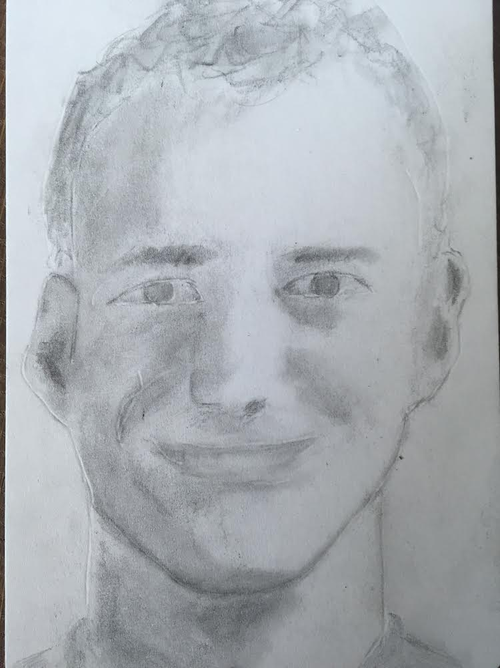

### Quick Takeaways

* Try drawing! Buy [this book](https://www.amazon.com/gp/product/1585429228/ref=as_li_tl?ie=UTF8&tag=tl0b6-20&camp=1789&creative=9325&linkCode=as2&creativeASIN=1585429228&linkId=4d8a5527b2e4aeb3d97be1d057705d25) and [this drawing set](http://amzn.to/2d3w2Ks).
* Drawing is great for TBI and the recovery process because it’s straightforward, you can start and stop when you want, and progress at your own pace.
* After twenty hours you’ll have a new appreciation of art and beauty and a profound new way to look at the world.

As a kid I liked art class, but never picked up a pencil or brush outside of it. Once high school hit, I took my one art requirement in photography and was done with it. I always liked going to museums but noticed that I gravitated not to the paintings but the blurbs so I would know what the “correct” thing to this about the painting was. I also thought of myself as a more literary/aural person than visual one.  
   
Until I hit my head, I hadn’t picked up a brush in ten years. But a doctor suggested it and it seemed relaxing so I have it a shot. I spent a month playing around with watercolor but there were too many new things to learn at once—the color, the different brushes, the water—alongside composition that it felt overwhelming to my concussed brain.  
   
I did make a Trump watercolor that came out ok.



Next an old art teacher from middle school—who had suffered a TBI of his own—suggested drawing and [Drawing on the Right Side of the Brain, the Workbook](https://www.amazon.com/gp/product/1585429228/ref=as_li_tl?ie=UTF8&tag=tl0b6-20&camp=1789&creative=9325&linkCode=as2&creativeASIN=1585429228&linkId=4d8a5527b2e4aeb3d97be1d057705d25).  
   
Here's my first self-portrait from April:

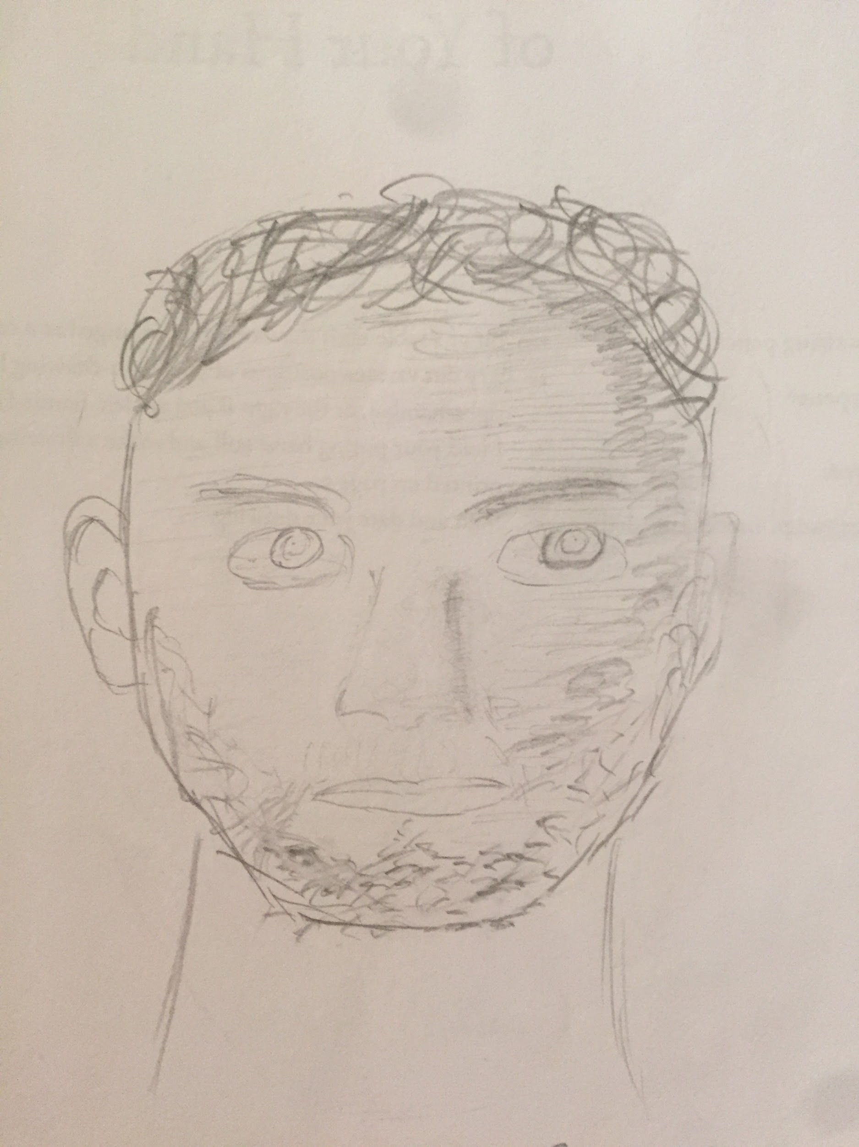

And another one I made after two months:



Drawing on the Right Side of the Brain was an absolute gift, and provided me the single best educational experience of my life (in a return divided by time invested sense). The book has 40 exercises, each one taking on average 15 minutes. They build off each other, teaching new techniques to allow you to draw what you see.

Why was this book great, particularly for TBI patients?

* It cut down on decision fatigue. You always knew what to do next, and never had to agonize about what to draw in what medium. Further, since you didn’t need an extra pad to draw on—all the exercises are conducted in the book—you had one less thing to misplace and have to look for.
* Light on text. In this book, particularly in comparison to other intro drawing books, there wasn’t a lot of text to wade through and what text there was was all essential. If reading is a trigger, this book is made for you.
* Bite size time chunks feel valuable. If you can only focus for twenty minutes at a time, this book can give you a sense of accomplishment in that limited window by just pressing your brain a smidgen to learn one new technique.

Drawing, while a solitary activity, helped me feel less isolated and withdrawn from my normal life. I bought these [postcards](https://www.amazon.com/Studio-Artists-Postcards-Peter-Pauper/dp/1441319727/ref=sr_1_5?ie=UTF8&qid=1475114965&sr=8-5&keywords=artists+postcards) and with some [fixatif](https://www.amazon.com/Krylon-1306-Workable-Fixatif-11-Ounce/dp/B00023JE7U/ref=sr_1_1?ie=UTF8&qid=1475114987&sr=8-1&keywords=fixatif) to seal in the graphite and made close to 100 personalized postcards to friends and professional colleagues. It was a great excuse to reach out to folks from out of town and let people know what I was going through. On the back I would write “Hey, I recently suffered a pretty serious concussion and can’t do much…but I have learned how to draw!” Getting nice thank you emails and postcards in return provided a great emotional boost.  
   
After finishing the drawing book, I started taking a class at the Arts Student League of New York. Though I was the only person in their mid-twenties—most were high schoolers or retirees—the environment was really friendly, welcoming and supportive. It provided an outlet to be social without having to talk all that much, and when I got too fatigued I could just leave the room for a bit without disrupting anything.  
   
More profoundly, learning how to draw has trained my eye and brain to look at the world differently. I notice more details and appreciate more beauty. Architecture has suddenly become interesting, and walking in parks I find myself looking at random leaves and flowers that used to never catch my eye. Museums have become way more enjoyable—I spend more time looking at fewer paintings, as I can now appreciate the artists’ skill much more deeply and think about what they’re trying to accomplish with their composition and technique. This new 'vision' is a true gift, and something I may never have been exposed to had the TBI not forced me into seeking out some habit as low-intensity as drawing.

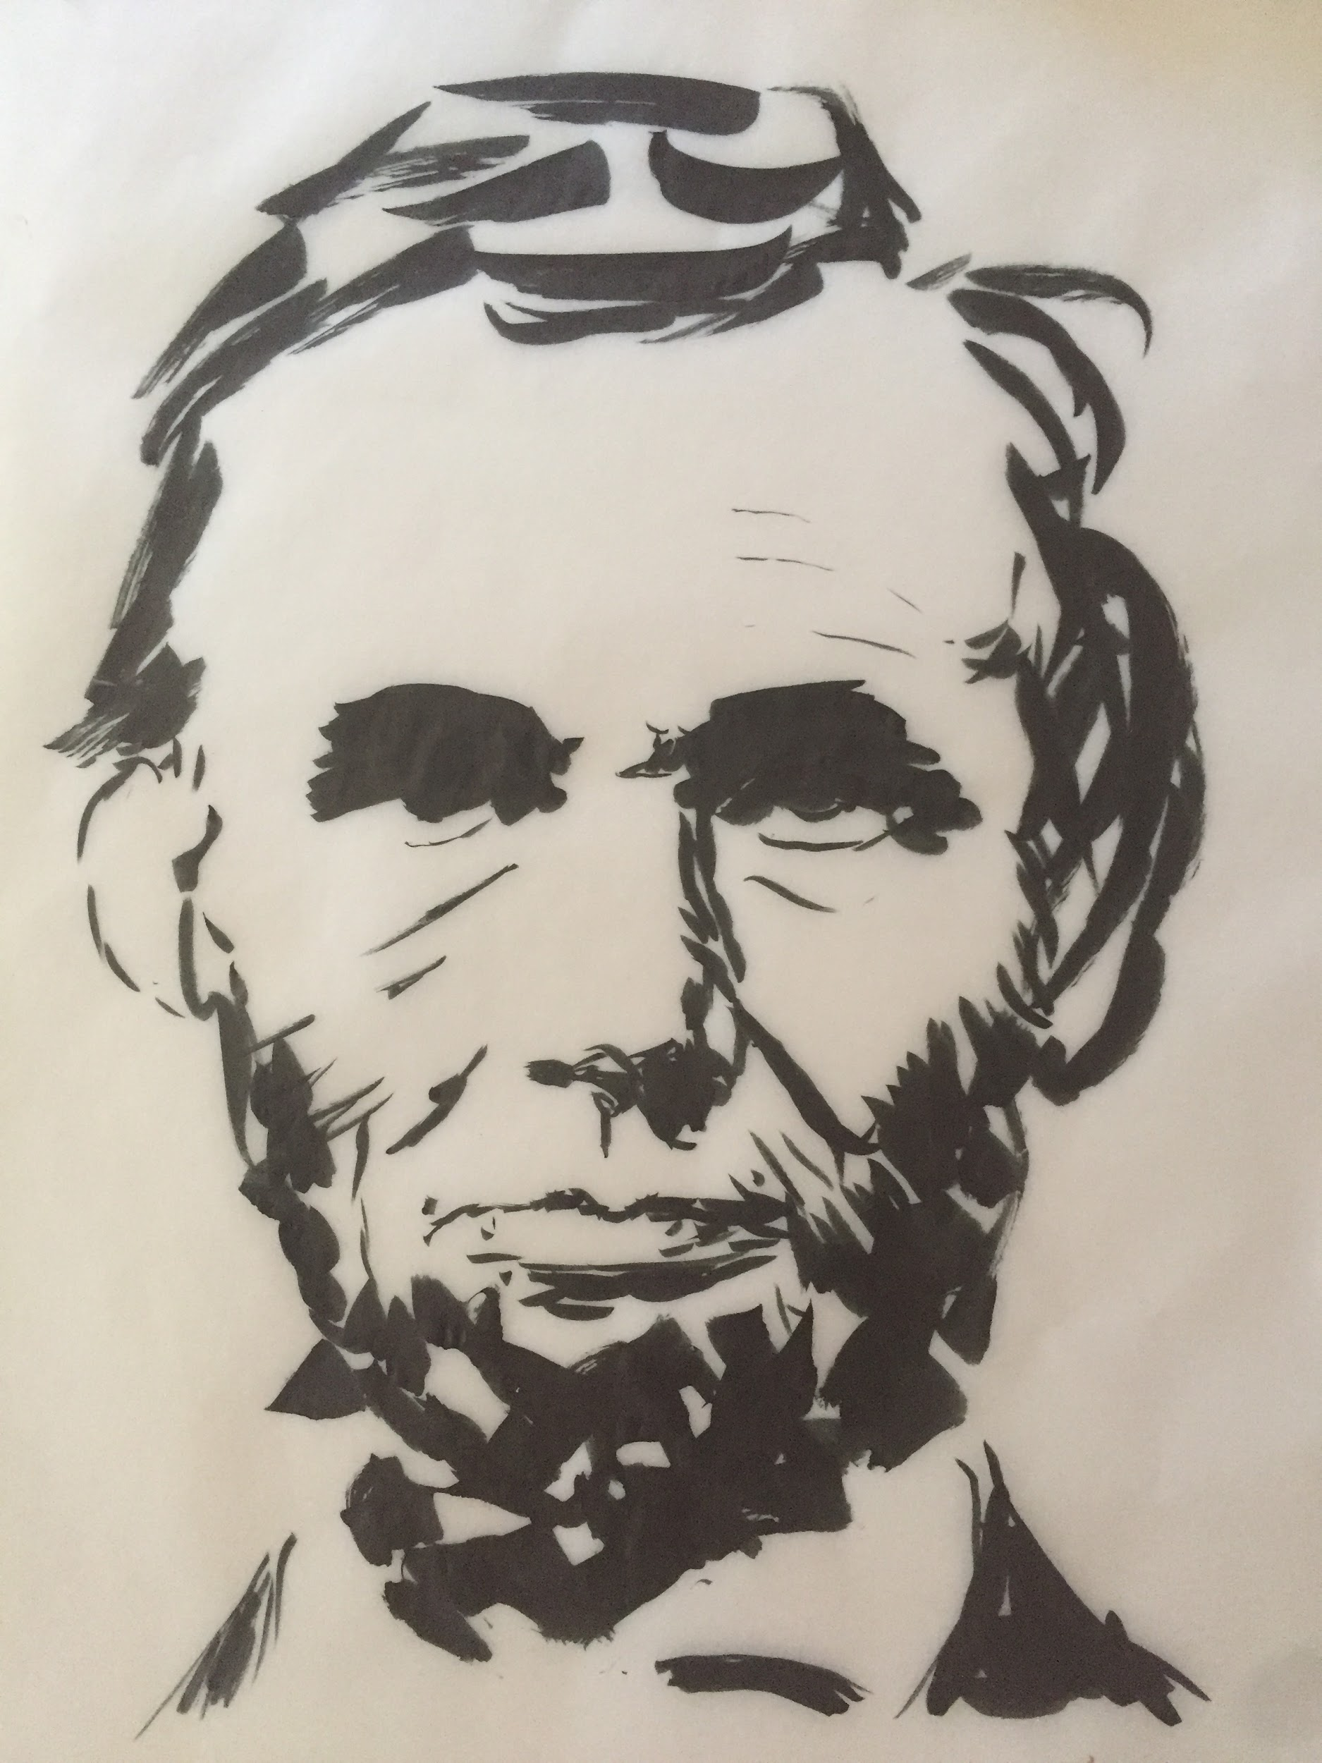

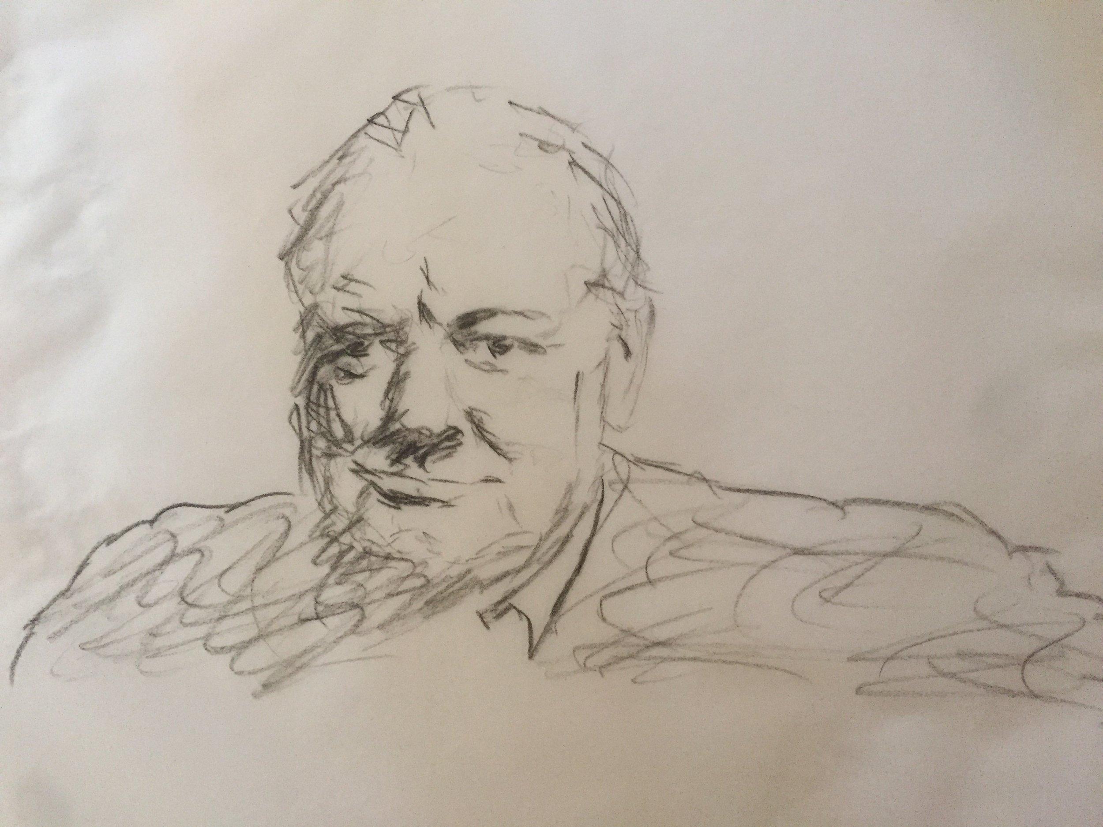

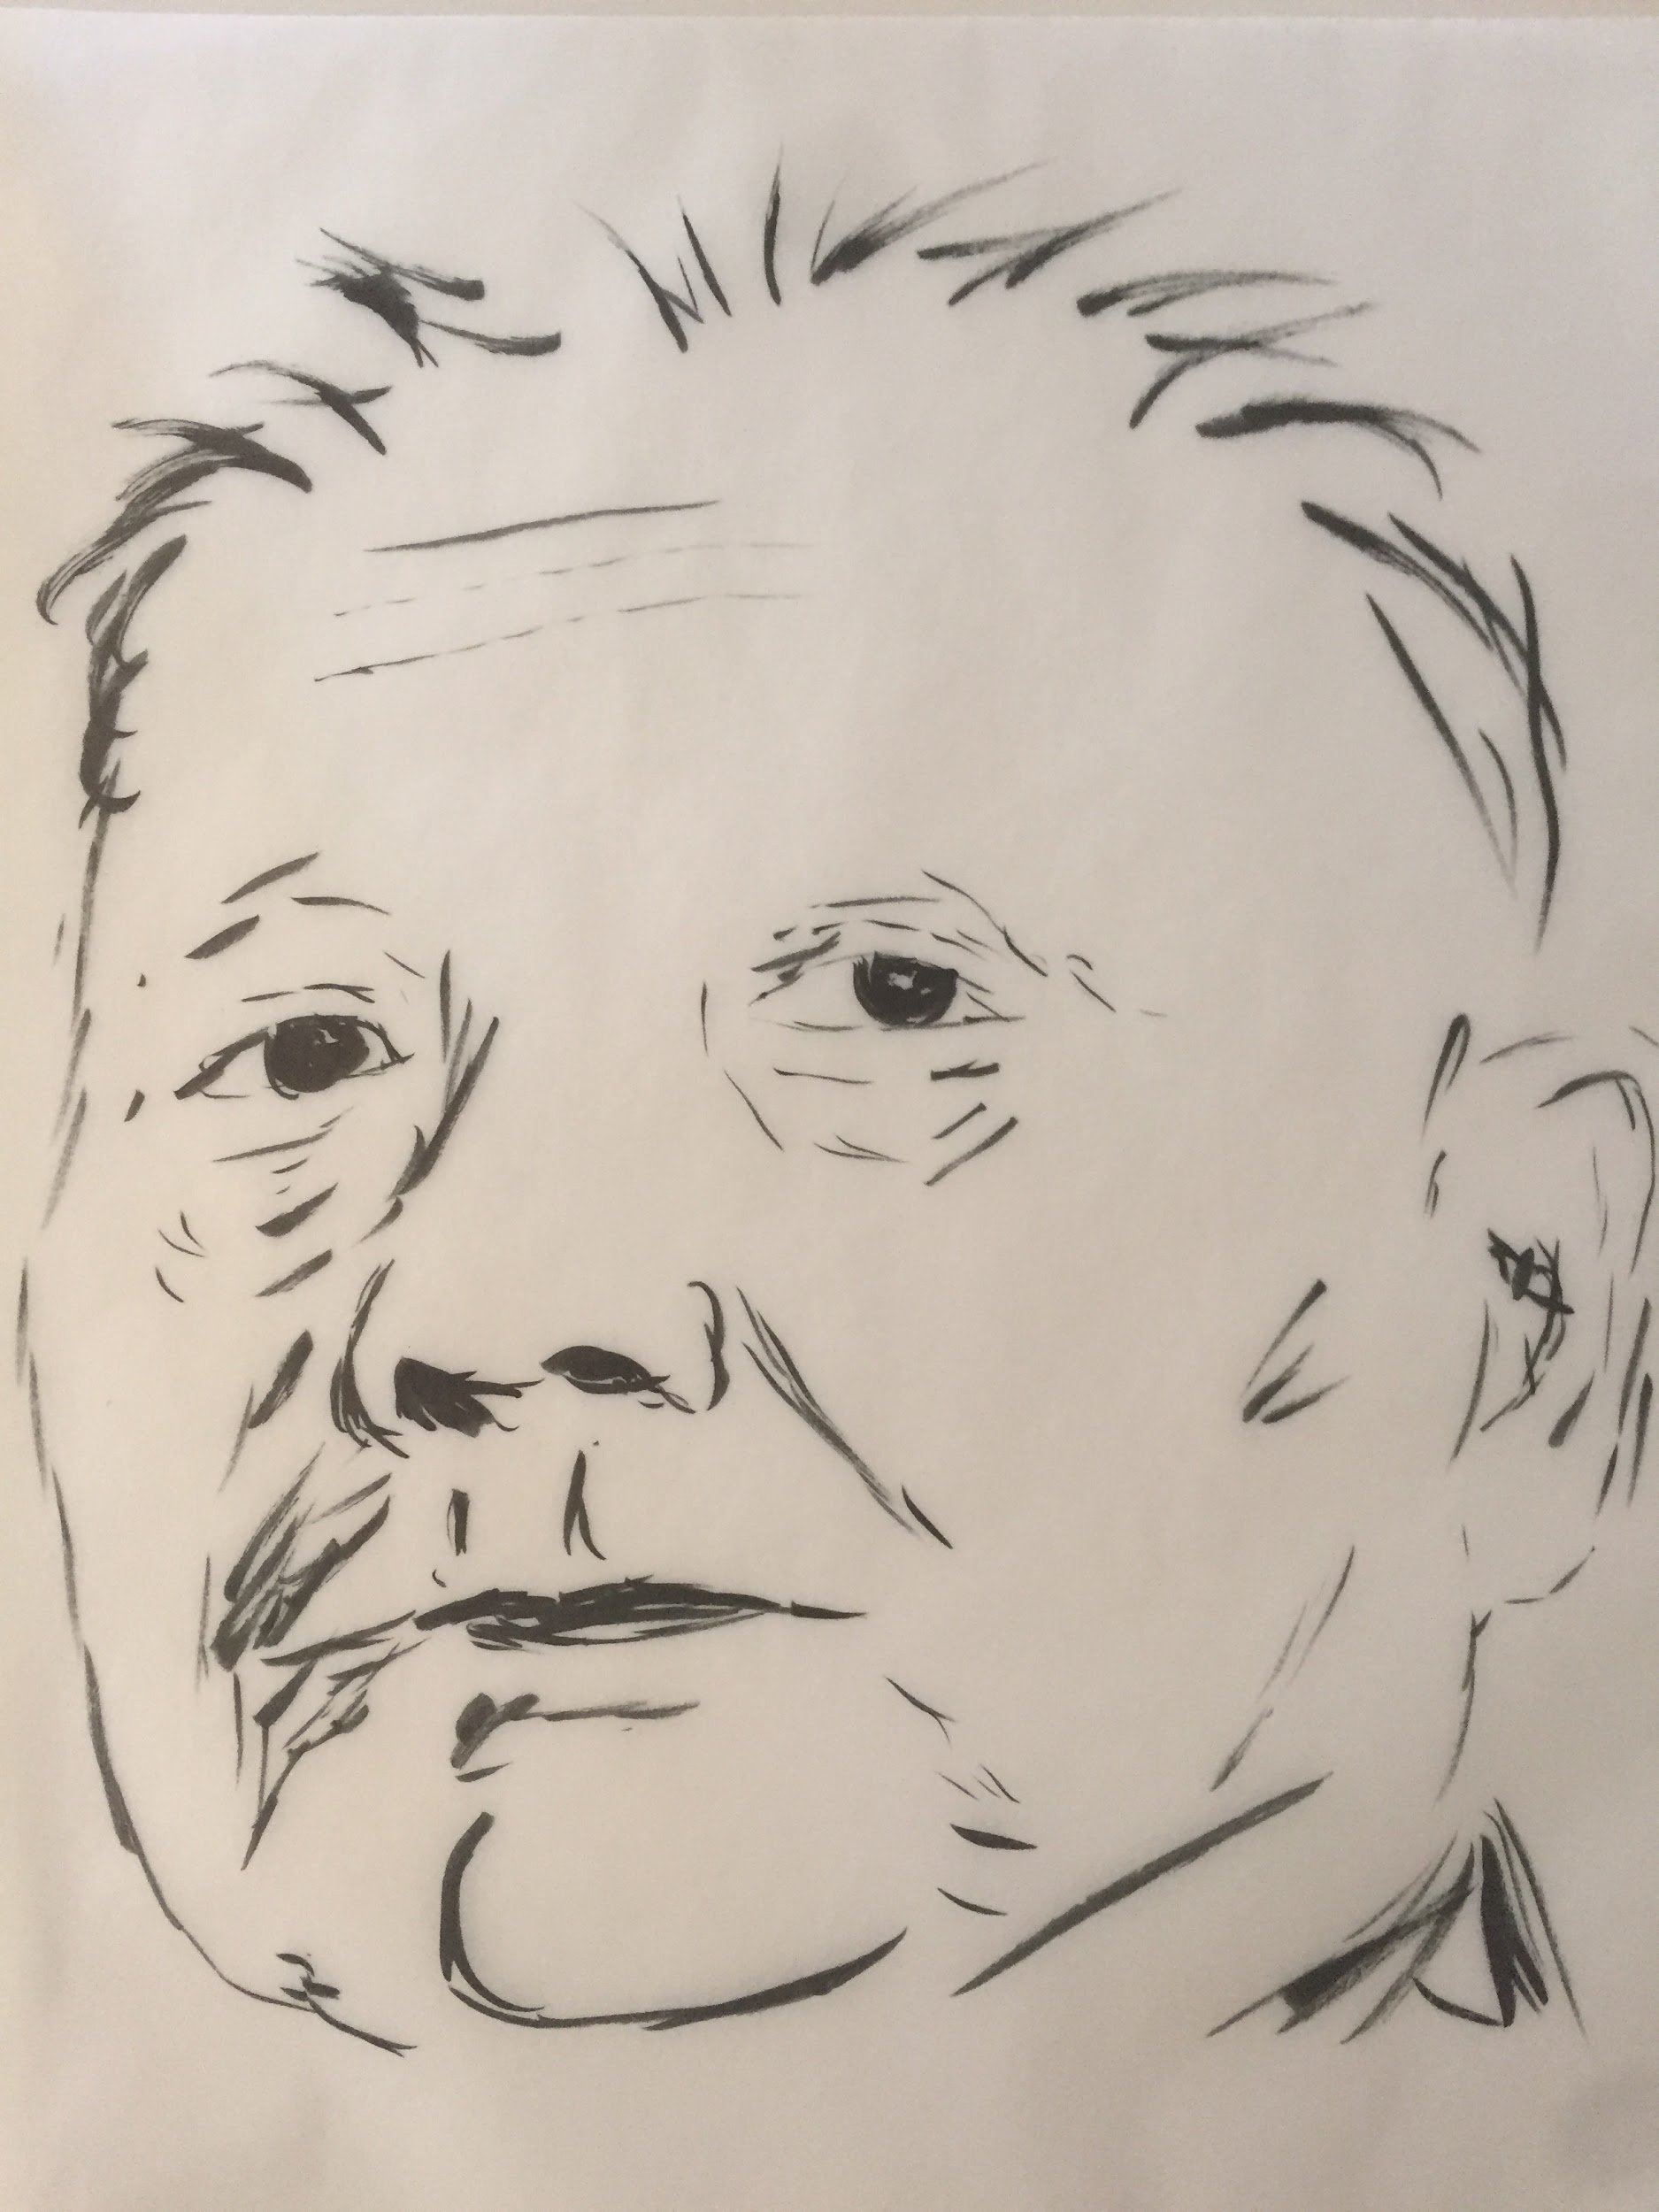

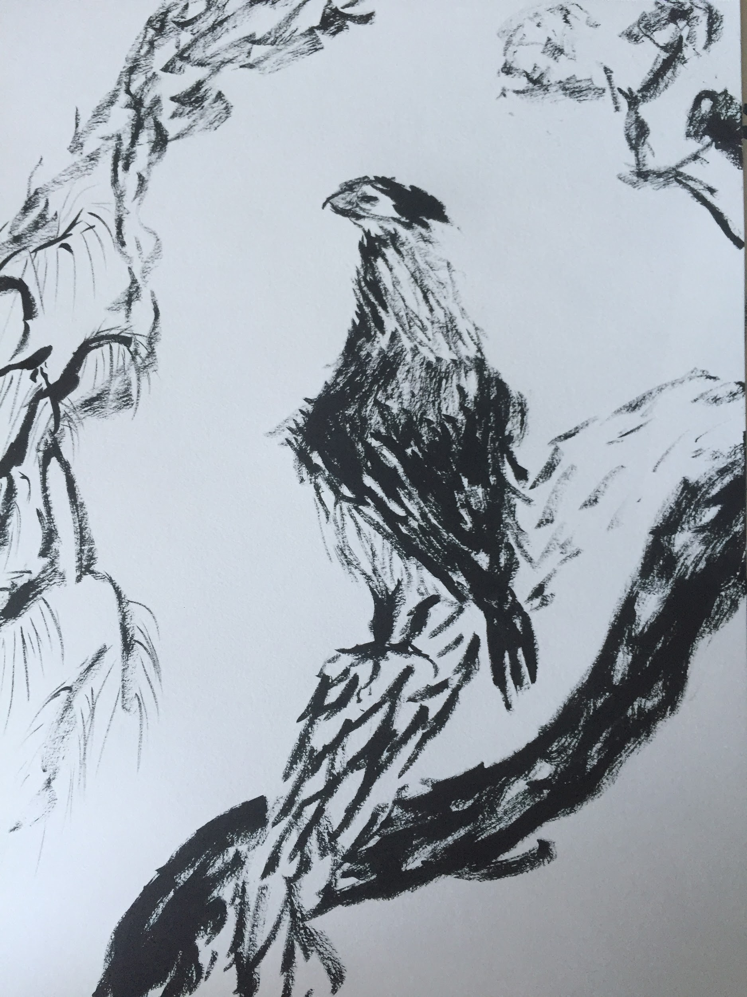

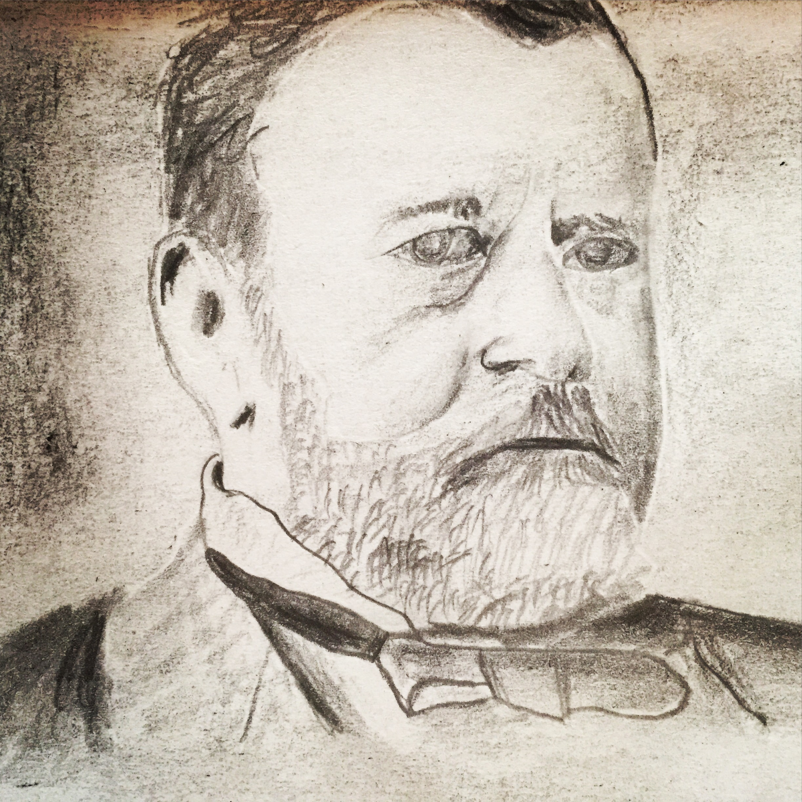

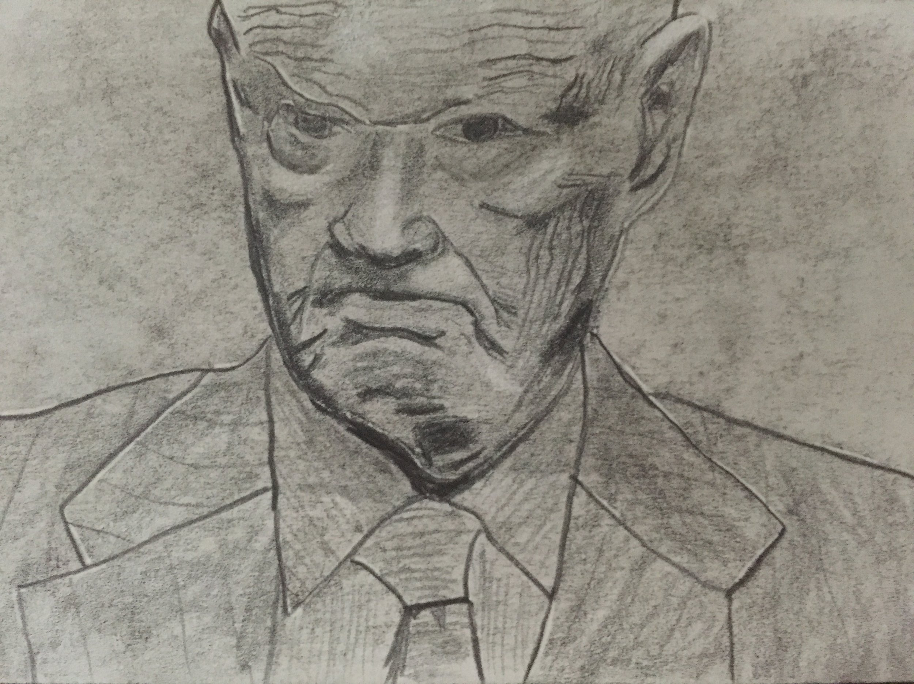

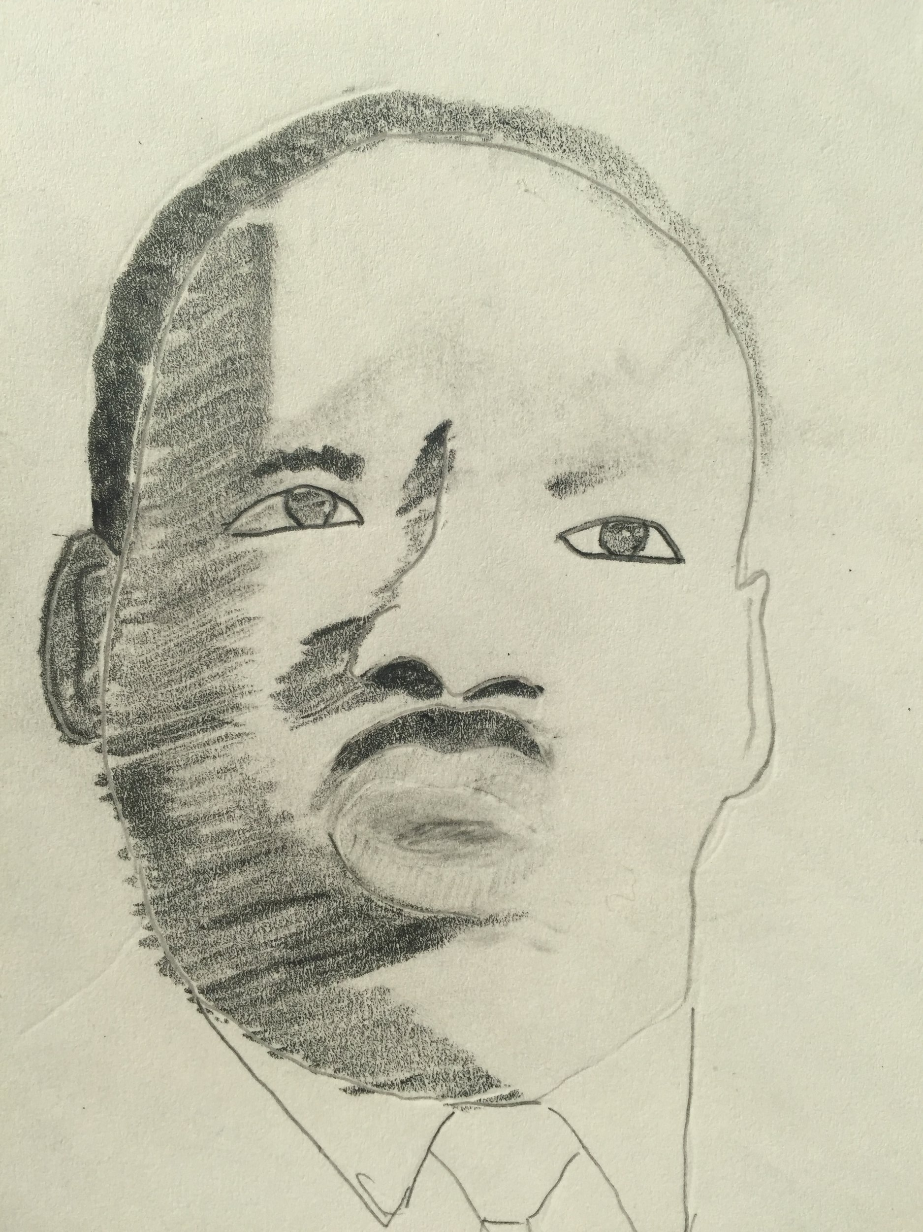



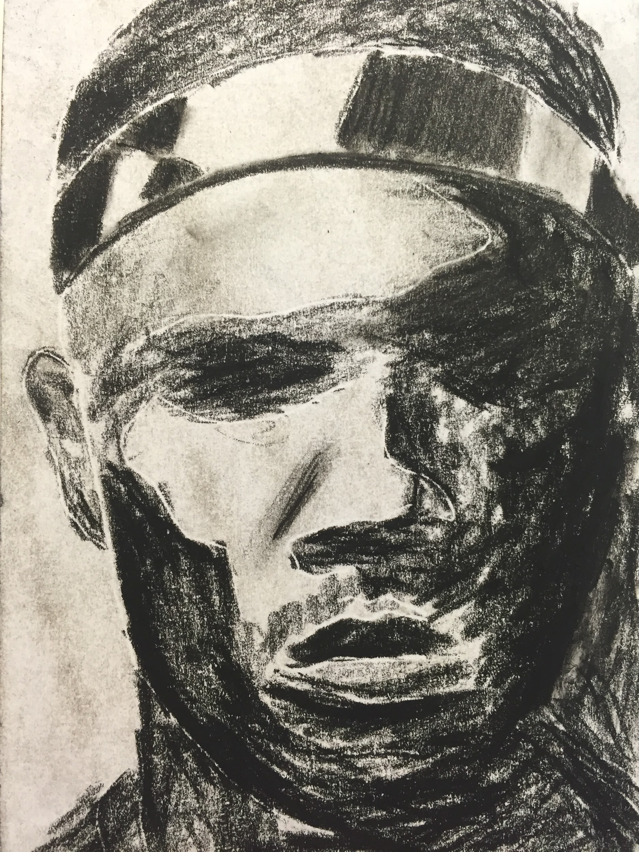

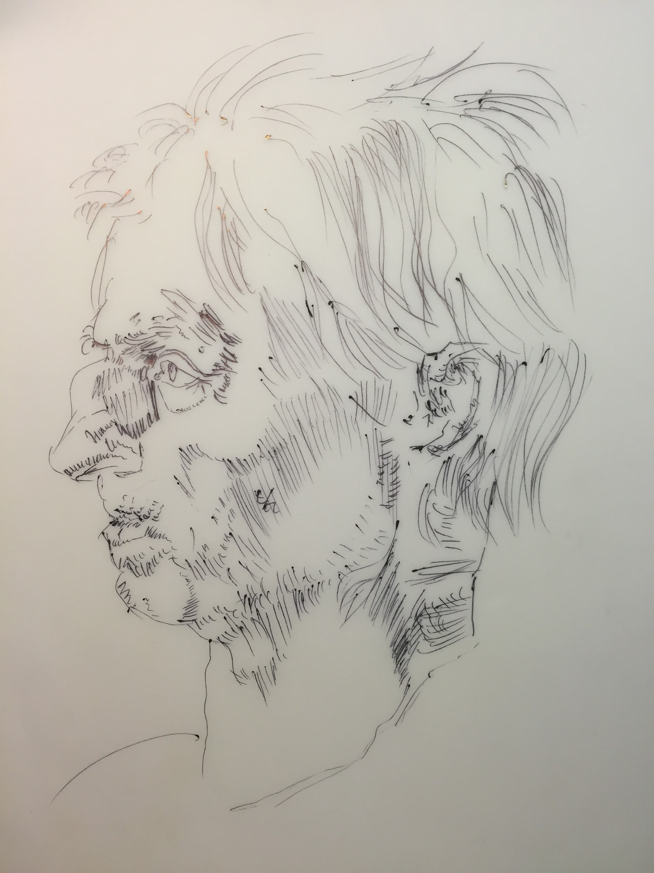

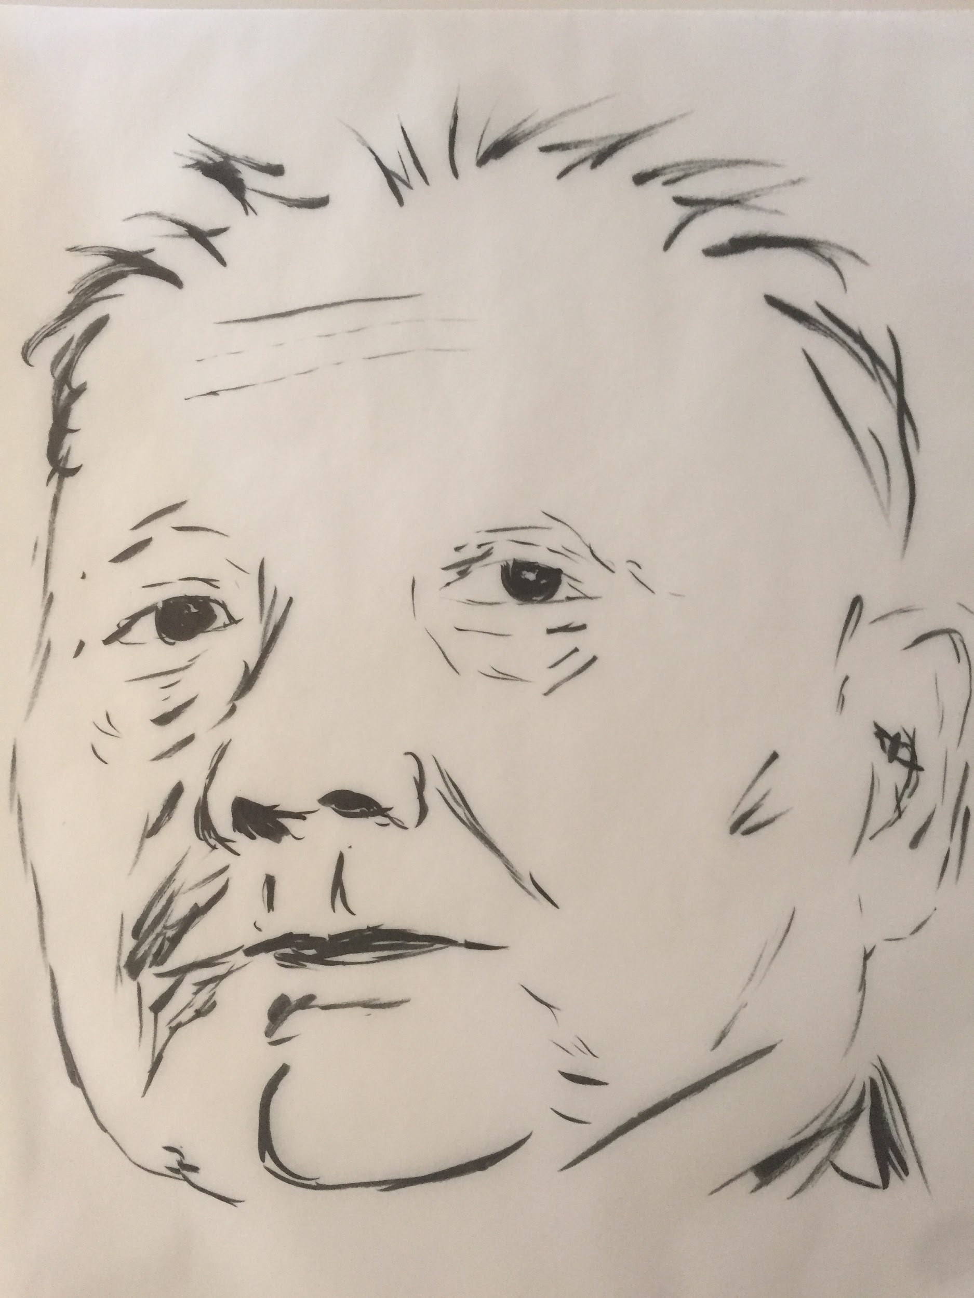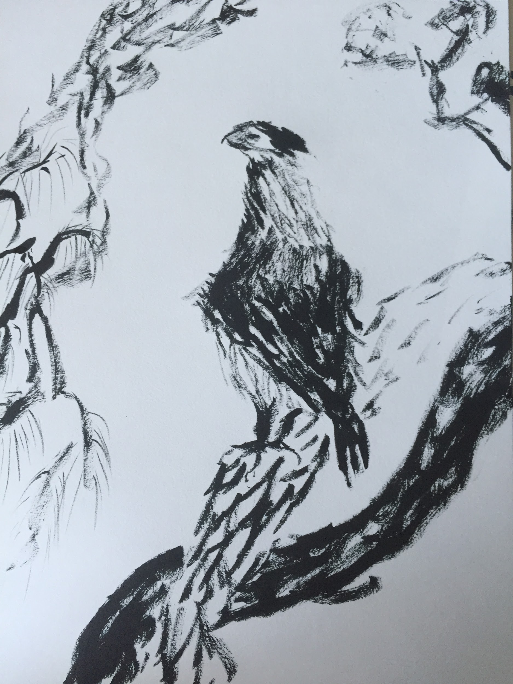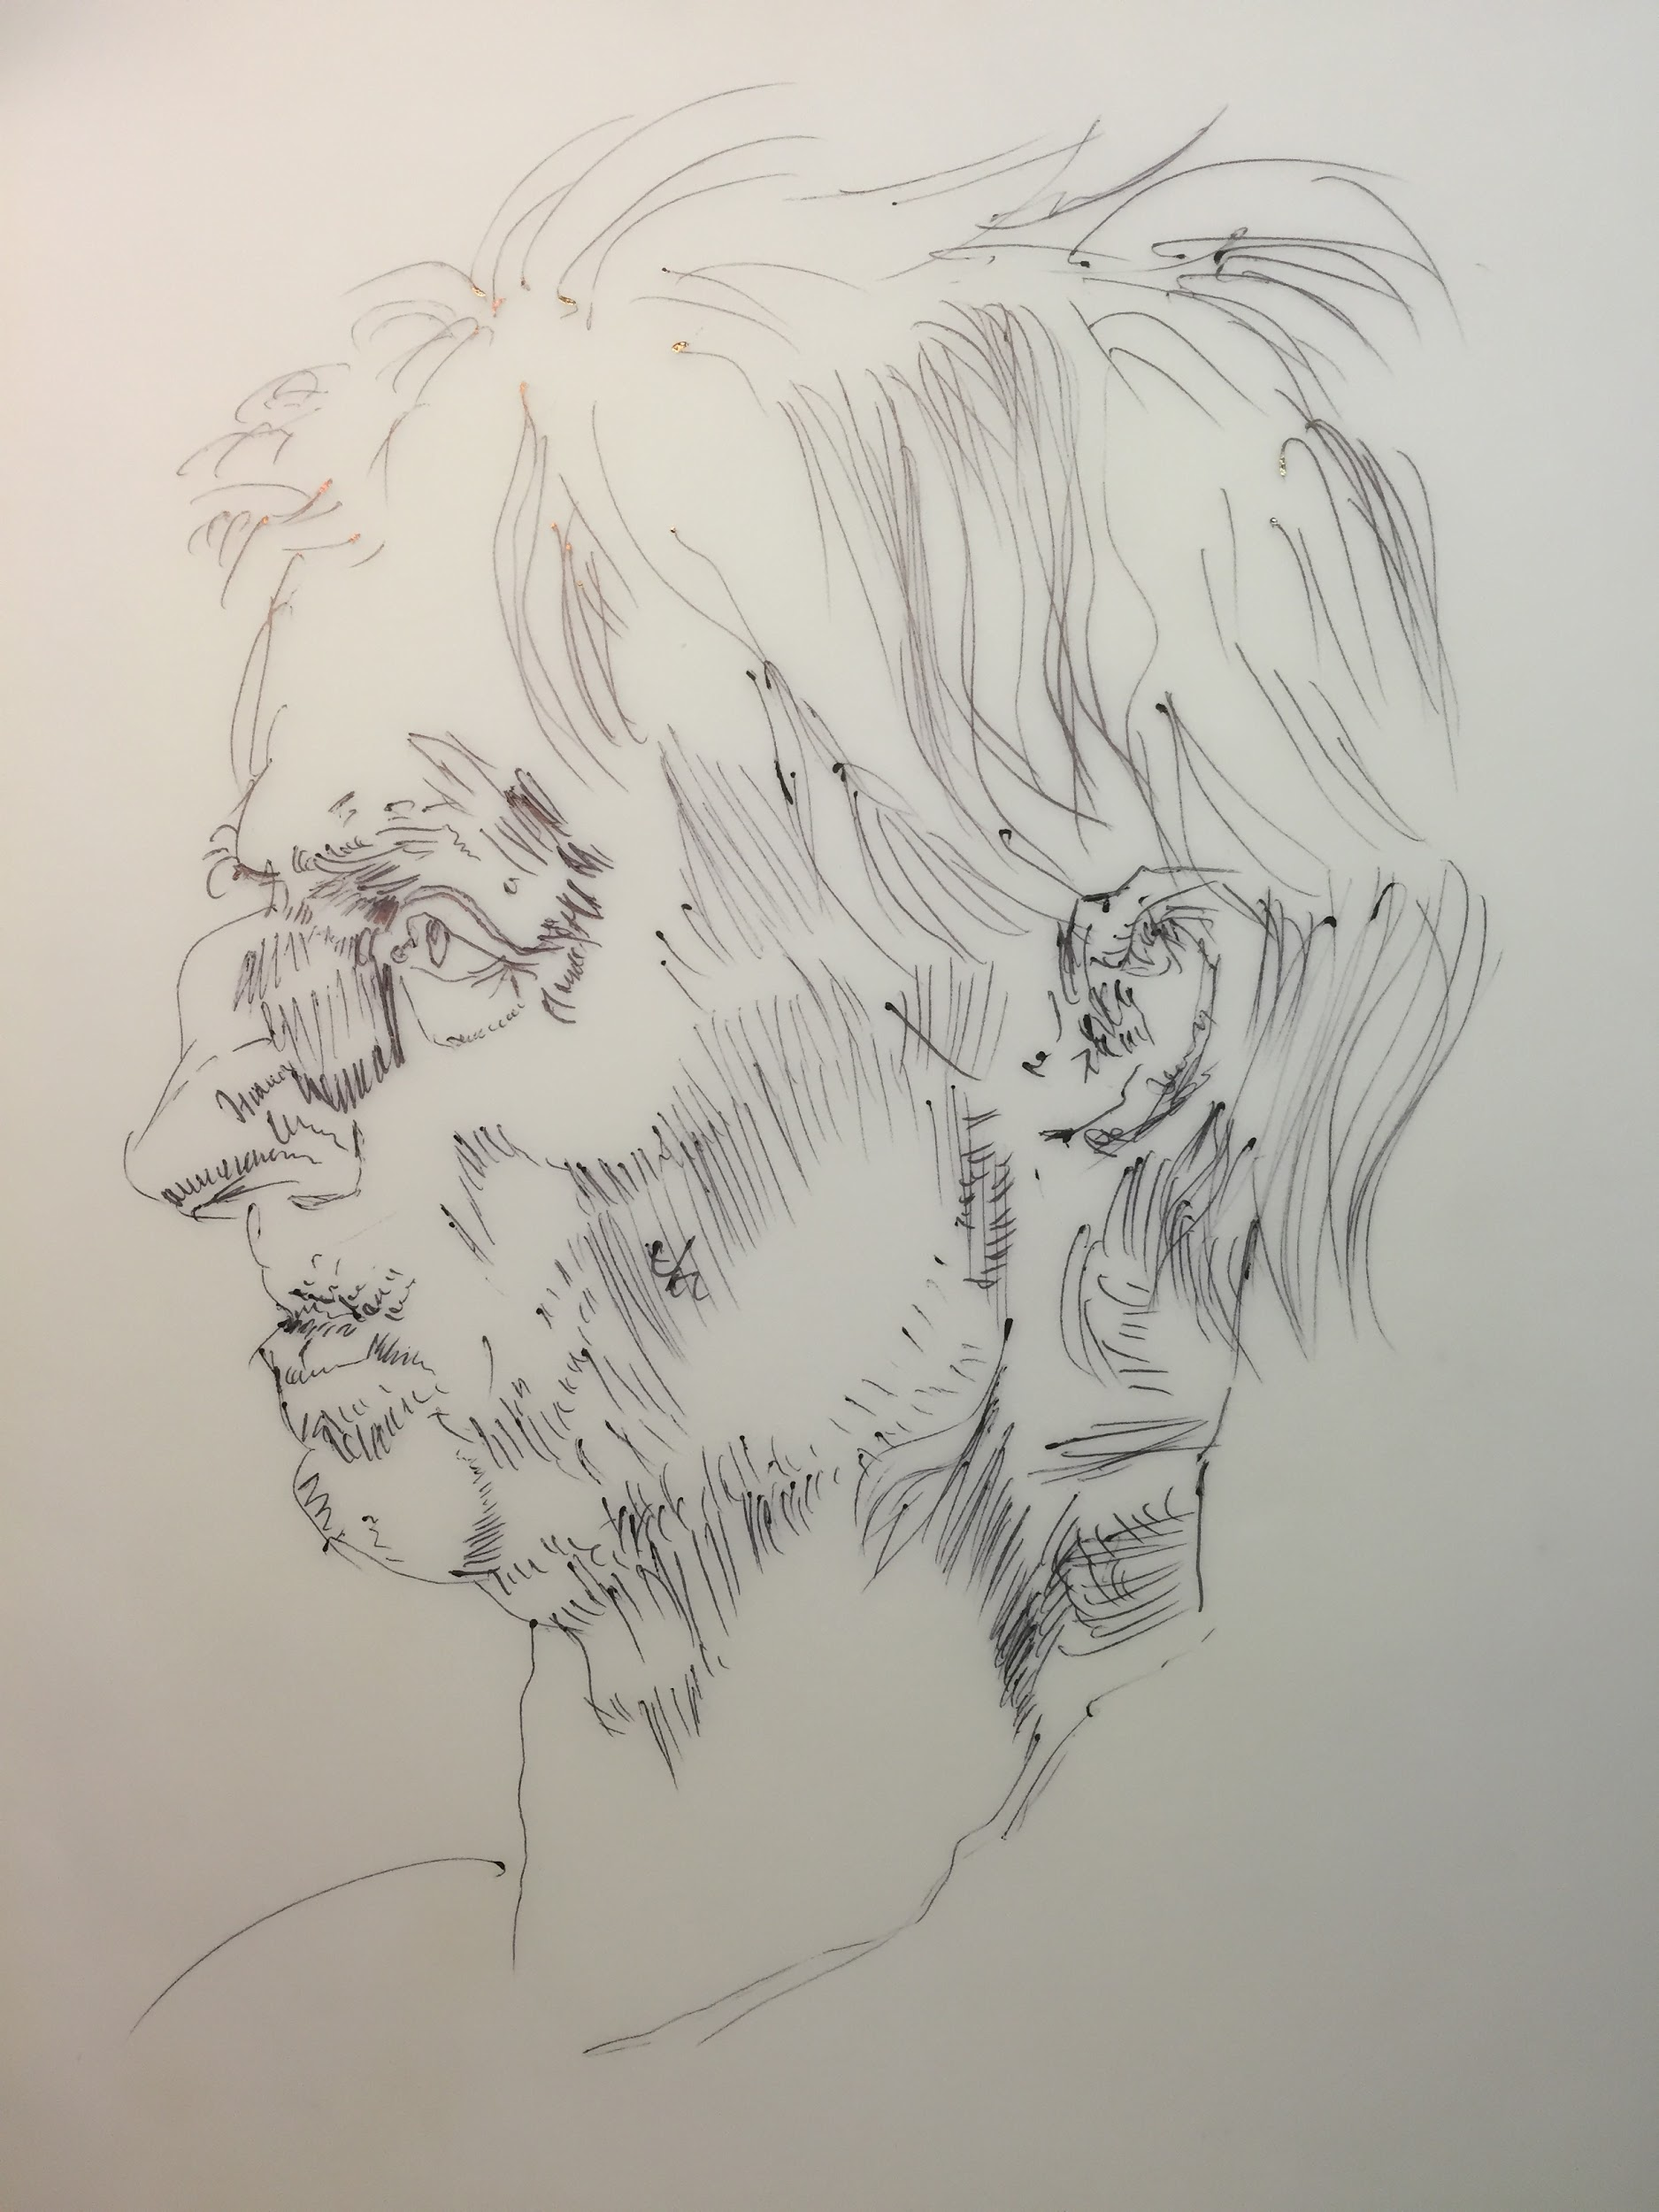

jordan schneider

# Mental Frames for Depression



## 1. Happiness is a Choice

The most profound thing I came across in self-help exploration so far is the idea that at the end of the day both happiness and suffering are choices. However incredible or awful your life may look on paper, you can control how you process and interpret the world around you.

[Naval Ravikant's interview](http://fourhourworkweek.com/2015/08/18/the-evolutionary-angel-naval-ravikant/) with Tim Ferriss illustrates this pretty powerfully.

## 2. Suffering is a Teacher and The Obstacle is the Way

“I had a health issue a few months back, which is a great wake up call. Everything great comes from something bad. Krishnamurti has this definition of suffering, where he says suffering is a moment when you see reality exactly as it is. When you face reality, that’s when you’ll change. It’s hard to look at suffering as a teacher but that’s how you should prepare yourself for it…I had a bacterial infection and my internal state was unhealthy. In one week I dropped alcohol, dairy, caffeine, red meat, went completely zero carb. All my bad habits disappeared overnight because my body was giving me a tight feedback loop. If I ate the wrong thing, I felt terrible. That was a gift! When I’m 41, my turns around and tells me what to eat to be healthy. If I ate perfectly, then the symptoms were much better.”

— Naval Ravikant

A great frame to adopt is that this journey can provide you so much more teaching than your average time going back and forth to work or school. What you're experiencing now will end up dramatically reshaping you for the better, empowering you to be a more willful, empathetic person.

Do listen to the [most recent Tony Robbins interview](http://fourhourworkweek.com/2016/08/10/tony-robbins-on-achievement-versus-fulfillment/) on the Tim Ferriss podcast right now. Skip to minute 35.

Again coming back to that [Naval Ravikant](http://fourhourworkweek.com/2015/08/18/the-evolutionary-angel-naval-ravikant/) interview.

As for books, or audiobooks if you can listen to things easier: Marcus Aurelius' Meditations (he'll get his own post soon enough--I liked [this translation](https://www.amazon.com/Meditations-selected-correspondence-Oxford-Classics/dp/0199573204/ref=sr_1_5?s=books&ie=UTF8&qid=1472484275&sr=1-5&keywords=marcus+aurelius+meditations)) and Ryan Holiday's [The Obstacle is the Way](https://www.amazon.com/Obstacle-Way-Timeless-Turning-Triumph/dp/1591846358).

For me, my mind has raced, occasionally recklessly, as long as I can remember. I’ve been uncomfortable with empty mental space and introspection — starting back in second grade I fell asleep with a radio on. As the things that I’ve used to divert myself from my mind — podcasts, reading, facebook, socializing — became physically painful, I’ve gone through an aggressive crash course in sitting with my thoughts. The mental journey has not been fun. However, honestly confronting and learning to mold my mental state has been the most profound silver lining of this experience.

## 3. The Importance of Gratitude

Every morning and night write down three things you're thankful for and try to reach out and thank one person a day for something. Your symptoms may be really terrible and you may feel like your prognosis is hopeless but if you're reading this blog you're most likely in the global 1%. If that's the case, you have a tremendous amount to thank fate for.

### Feeling really desperate?

Tell someone. Call 1-800-273-8255 right now.

I liked [this also](http://fourhourworkweek.com/2015/05/06/how-to-commit-suicide/).

Lastly, it's helpful to know that you're not alone. WebMD tells me that around half of those suffering from PCS confront depression in their first year. Your brain is playing tricks on you but you will get better and come out stronger for it.

# Good TBI TV



TV is tricky. It's the default low-intensity "I'm sick around the house with nothing to do" activity, but it can also trigger. I'm a big fan of 'great tv' (The Wire, Mad Men....etc) but trying to watch these shows is an exercise in frustration. You'll either be diligent in listening to your body and have to pause all the time or close your eyes to listen and miss out on a lot of subtlety, or the shows will be too good that you'll watch too much and overexert. What you thought of as good TV probably isn't the same as good TBI tv. So, what makes for good TBI TV?

1. You can watch by listening half the time and not miss much

2. Relatively formulaic

3. By and large uplifting

Some suggestions:

## **The Great British Bake Off**

Unlike US-based cooking shows like Chopped and Top Chef, The Great British Bake Off is super super chill. The shots are really slow, and since its baking instead of cooking there's alot of waiting around and drama in whether stuff will come out of the oven right. Everyone's friendly and supportive and both the hosts and contestants come off as decent people.

Spencer Ackerman [described it as](https://www.theguardian.com/tv-and-radio/2016/sep/14/i-love-the-great-british-bake-off-not-mel-sue) "televised Lexapro for an anxious world, an idyll where ambition, creativity, competition and glory co-exists with warmth, generosity, fellowship and grace."

You can find one season on Netflix (it's called The Great British Baking Show) and others on various corners of the internet and youtube. Maybe it will even inspire a new hobby!

## The Profit

They did some study saying that where Teen Mom teen pregnancy went down. I'd like to think the same has happened for shows like Shark Tank and The Profit and American entrepreneurship.

The cuts are faster than Great British Baking Show but still relatively slow. Marcus Lemonis also seems like a decent human being.

My favorite shows are the ones where the business owners are relatively humble and don't get into big shouting matches. You can find a site that highlights them here.

## Sports?

Sports are a tricky one. Oftentimes when sports are at their best you get too invested in the game, lose track of your limits, and overexert. My biggest setback I had involved a long day where I knew I should've just gone to sleep at 8pm...but game 6 of what turned out to be a classic between OKC and the Dubs was on. If you're a fan, try to be mindful that live sports can really tempt you to break a "ten min on/ten min off" screen regimen because you want to be on twitter seeing what everyone else is saying about the last Kyrie crossover.

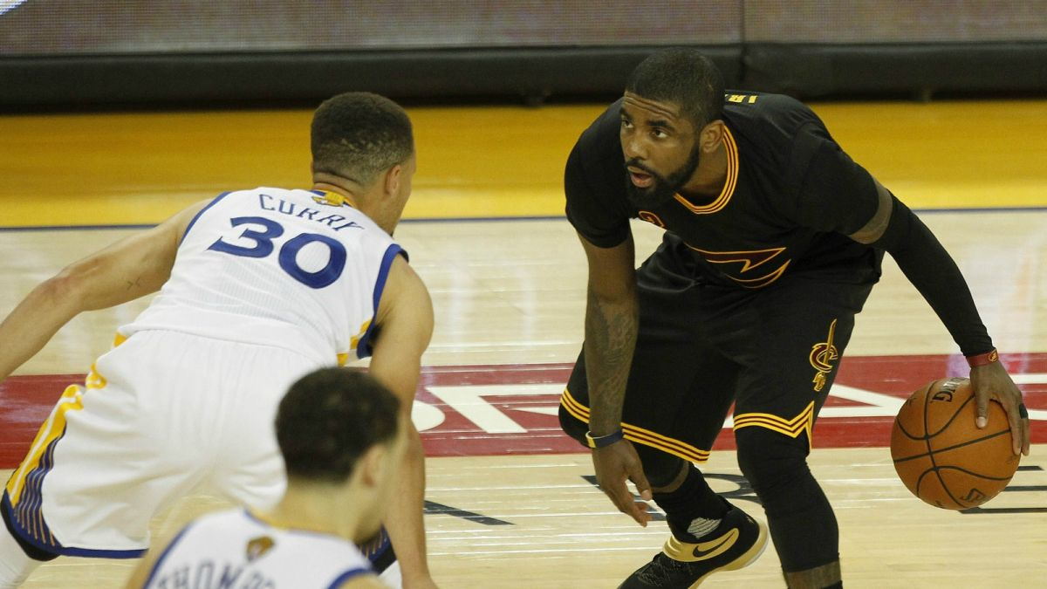

And a final word to the wise: Stay away from illegal streams! Wading through flashing pop-ups and watching blurry live feeds with low resolution and frame rates can really mess with your brain.

# Biofeedback HRV: Breathing as Superpower



## Key Takeaways:

## Many TBI patients have slower recoveries and constant anxiety because their nervous system isn't letting them relax and recharge

## Slow breathing (3 count in, 5 count out) into your diaphragm twice a day for 20 minutes can do wonders

## By week 4 or so you end up a superpower that in five breaths turns on the chill, flow nervous system. This becomes a great non-invasive tool for managing pain and anxiety, as well as speeding up recovery

So, what's the autonomic nervous system? Glad you asked. This video has lots of visuals that may trigger so feel free to just listen to it.

The idea of biofeedback heart rate variability breathing is to turn on your chill nervous system. The sympathetic/parasympathetic divide isn't one you can generally have conscious control over, but there is one hack humankind has found: super slow (5-6 breaths per minute) and regular breathing patterns. This tells the brain and body that no, there isn't a lion about to eat you for brunch, and you'll be ok if you relax.

Here's a pop take:

Or if TED-style stuff turns you off, listen to Richard Gervitz, one of the leading scholars who brought this technique from the realm of yogis to modern medicine, explain (the first 15 min will get you the gist).

Lots of concussion patients have really low heart rate variability--the main indication that they're stuck in the sympathetic nervous system. To help the body regain the ability to switch back to the parasympathetic system, consider starting with slow breathing.

How do you do this? Well, at first, you should download a breath timer. I used [BreathPacer](https://itunes.apple.com/us/app/breathpacer/id291943364?mt=8), a sort of old iPhone app that cost $3, but was simple enough to not get in the way. Use their recommended setting for your height and maybe play around with it a bit to find somewhere that's comfortable, but try to aim for a time in the 5.5-6.3 breaths per minute range. Turn your phone onto airplane mode, then set the timer on the app for 20 minutes.

Next, start it up, and concentrate on feeling your breath come in through your nose and down into your abdomen. Then exhale through your mouth, breathing out not aggressively but smoothly, like you're blowing on some soup to cool it. Whenever you have some thought that pops into your head, note it (say internally "that's a thought" or "that's a feeling"), and focus back on your breath. Repeat for 20 minutes.

I had about a month of meditation training on Headspace that helped me calm and focus. That said, my mind has raced constantly for 25 years so it's not like I was the chillest person coming into this. The brain can be trained just like any other muscle, and

So, what's the payoff?

The closest you ever want to get to feeling high on heroin. Well, at least the first 3 minutes of what Lou Reed's getting at.

You fall into this blissed out focus and calm state which I've never felt before. After doing hrv breathing for a few weeks, I dropped my phone 14 stories down an elevator shaft. I felt the stress response coming on, then said, you know what, I'm going to take 5 breaths now and see how I feel. The world seemed way less scary and my head started to hurt less.

### It feels like a superpower. After a lifetime of having the world act on me and have circumstances bring about certain emotions, I now feel much more in control of how I'm feeling at any point in time. It comes back to what I wrote in the mental frames post. First you have to recognize that suffering and happiness are choices. Then, HRV training gives you the toolset to live that belief.

Getting control of these stress responses gives you a lot more power over your symptoms. For me, the stress response was intimately connected with spikes in pain and nausea. By breathing through these periods, I was able to bring 5 and 6/10 headaches down to 3's and 4's without having to lie down and stop what I was doing. After getting fatigued in a conversation and thinking I was going to have to go home, I spent two minutes breathing and felt refreshed enough to continue without leaving the restaurant. It allowed me to interrupt fear and anxiety cycles that triggered pain.

There's also science saying that by giving your body these forty minutes a day with the sympathetic system in charge, you break out of that locked parasympathetic state and your body starts to accelerate its recovery.

# 

# Podcasts

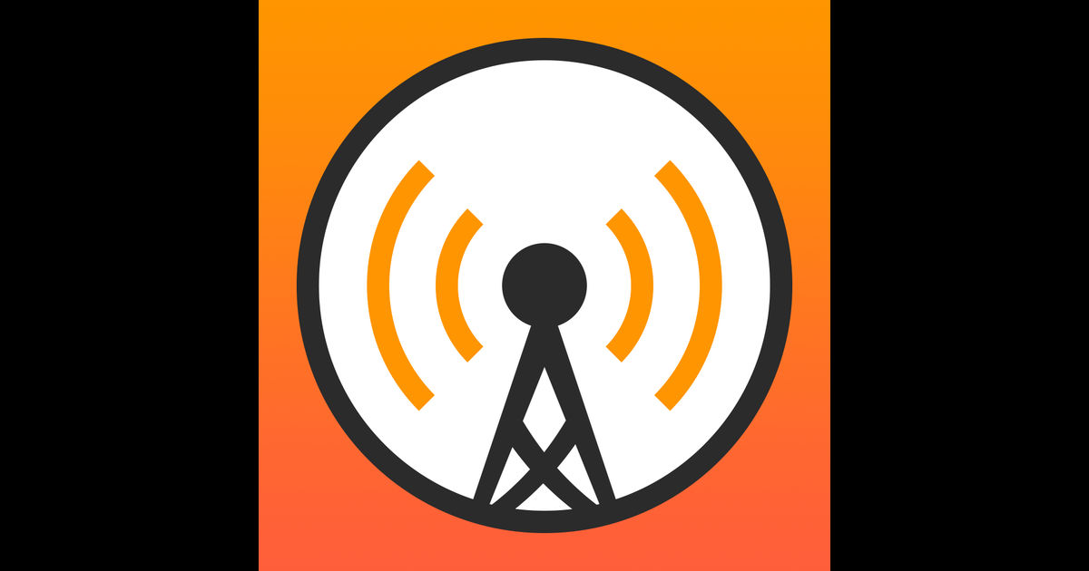

Reading can get hard post-concussion. Podcasts are a great way to pass time and keep your brain active.

Note: Check out the [Overcast](https://overcast.fm/) app to download and manage your podcast. They have a slow dial you can use to increase your podcast speed as a way to do progressive mental overload.

## INTERVIEW-BASED PODCASTS

I found that interview-based podcasts are a great first step to getting your brain to consume media again. Since there's some dead-time and small-talk built into interviews, particularly loosely edited ones, your brain has more space to breathe.

[Tim Ferriss Podcast](http://fourhourworkweek.com/top-10-podcasts/)

I stumbled on Tim Ferriss after listening to him get interviewed on the [Freakonomics](http://freakonomics.com/podcast/tim-ferriss/) podcast. He seemed like an interesting dude with lots of cool [lifehacks](http://fourhourworkweek.com/2013/11/03/productivity-hacks/). I figured that if I came out of my concussion with a handful of new habits that I could be proud of, that would make me feel less like the past six months have been a total waste.

Each episode features a different person who is a world class performer in a random field (VC kingpin, US Olympic strength training coach, chess master, Army general, CEO...). Ferriss spends 1.5 to 3 hours talking to them about how they got to where they are

The first few of his I listened to were unbelievable. Here are five to get you hooked.

* [Naval Ravikant](http://fourhourworkweek.com/2015/08/18/the-evolutionary-angel-naval-ravikant/), about life and meditation
* [Tony Robbins](http://fourhourworkweek.com/2016/08/10/tony-robbins-on-achievement-versus-fulfillment/) on choosing your mindset (skip first 30 min)
* [Jane McGonigal](http://fourhourworkweek.com/2015/07/28/jane-mcgonigal/) on her concussion recovery (first 30 min)
* [Jamie Foxx](http://fourhourworkweek.com/2015/12/06/jamie-foxx/) on his life story
* [Glen Beck](http://fourhourworkweek.com/2015/04/06/glenn-beck/) (no, really) on his life story

After a few episodes Ferriss may start to grate on you. I just wish he took more cues from a [Terry Gross](http://www.npr.org/programs/fresh-air/) and listened better, wasn’t as rigid in his schema/stock questions (I don't really care whether Jamie Foxx drinks coffee) and humble-bragged less. But you can always skip ahead when he talks!

### [Fresh Air](http://www.npr.org/programs/fresh-air/)

Terry Gross for my money is America's greatest living interviewer. The preparation, care, listening ability, and sense for when to press for more she has developed over decades is unmatched on TV or radio. She's at her best talking to artists, comedians, directors, and actors. Dive into [her archive](http://www.npr.org/series/10170626/-fresh-air-turns-20) and get ready for a real treat. [Search](http://www.npr.org/programs/fresh-air/) almost any celebrity you admire. Highlights include her with Bill O'Reilly, Mel Brooks, Joan Rivers, Jay-Z, and Maurice Sendak.

### [Econtalk](http://www.econtalk.org/)

Russ Roberts is an economist who hosts a weekly hourlong discussion about heady topics. He brings on economists, CEOs and writers to discuss some public policy or ethical issue. I like that he does his homework and asks prodding questions without being a jerk, engaging in the sort of adult conversation I wish could be more common in modern American discourse. Russ is a committed libertarian, and while I don't necessarily agree with much of his politics, he articulates his views in a really intellectually honest manner that you rarely hear from other academics. Here are some best-of lists from [2015](http://www.econtalk.org/archives/favorites/) and [2014](http://www.econtalk.org/archives/2015/02/your_favorite_e.html) to get your started. This one on [potato chips](http://www.econtalk.org/archives/2011/08/odonohoe_on_pot.html) is also brilliant.

## Produced Podcasts

Once you feel comfortable with interviews, produced podcasts with sound effects and tighter editing can provide another level of mental challenge.

### [99% Invisible](http://99percentinvisible.org/)

This show makes the endless walks around town you take way more engaging. It's a 20-30 minute show about design that had me thinking about streets, buildings and objects in new ways. A few to spark your interest

* [inflatable people](http://99percentinvisible.org/episode/inflatable-men/) you see at car dealerships
* [airport design](http://99percentinvisible.org/episode/walk-this-way/)
* a cultural history on [how cars took over American streets](http://99percentinvisible.org/episode/episode-76-the-modern-moloch/)
* [Spy stations on shortwave radio](http://99percentinvisible.org/episode/numbers-stations/), best listened to at night

### Radiolab

The first podcast to really up production values and bring back '[radio play](https://en.wikipedia.org/wiki/Radio_drama)' aesthetics modernized for today, this NPR standby explores science broadly defined. They've created [the most beautiful piece of radio](http://www.radiolab.org/story/110206-finding-emilie/) I've ever heard. Some of my favorites include

* [Colors](http://www.radiolab.org/story/211119-colors/)
* [Desperately Seeking Symmetry](http://www.radiolab.org/story/122382-desperately-seeking-symmetry/)
* [Space](http://www.radiolab.org/story/91520-space/)
* [Sleep](http://www.radiolab.org/story/91528-sleep/)
* [Parasites](http://www.radiolab.org/story/91689-parasites/)

There are also plenty of episodes about the brain if you're not sick of learning about it.

* [Your brain on love](http://www.radiolab.org/story/91744-this-is-your-brain-on-love/)
* [Inner voices](http://www.radiolab.org/story/301401-inner-voices/)
* [tDCS](http://www.radiolab.org/story/9-volt-nirvana/)

## Download [Overcast](https://overcast.fm/) to listen to your podcasts

It's a much better manager than the generic iPhone app. You can fine tune the speed of your podcast, and use the accelerating speed as a way to [progressively overload](http://www.bodybuilding.com/fun/goulet11.htm) your brain and keep it from getting stagnant.

### 